## Visoka skola strukovnih studija za informacione i komunikacione tehnologije

**CodeFreakz**

<https://code-freakz.herokuapp.com/>

Smer: Internet tehnologije

Modul: Web programiranje

Predmet: Web programiranje PHP 2

Andrej Zarkovski 22/18

**Sadržaj**

Visoka skola strukovnih studija za informacione i komunikacione tehnologije 1

1.Uvod.................................................................................................................................... 5

**Korišćeni programski jezici** 5

**Opis funkcionalnosti** 5

2.Organizacija 7

**Organizaciona šema** 7

**Mapa sajta** 9

**Opis stranica sajta** 11

Home 11

Courses 13

Contact 15

About 16

Login 17

Register 18

403 19

Admin/content/courses 20

Course/create 21

Course/details 23

3. Kodovi....................... 25

Fajl ogranizacija 25

Controllers 30

AboutController 30

AccountController 30

AdminController 32

AuthorController 34

CategoryController 36

ContactController 38

CourseController 39

FrontendController 43

HomeController 44

LanguageController 45

StatusController 47

**Requests** 48

AuthorCreateRequest 48

AuthorUpdateRequest 49

CategoryCreateRequest 50

CategoryUpdateRequest 51

CourseCreateRequest 52

CourseEditRequest 54

LanguageCreateRequest 56

LanguageUpdateRequest 57

LoginRequest 58

RegisterRequest 59

Models 60

Author 60

Category 61

Course 62

CourseSection 63

Difficulty 64

Image 65

ImageType 66

Language 67

Menu 68

MenuItem 69

Role 70

User 71

Migrations 72

Seeders 73

AuthorSeeder 73

CategorySeeder 74

DifficultySeeder 75

ImageTypeSeeder 76

LanguageSeeder 77

RoleSeeder 78

**Views** 79

Common 79

Fixed 79

Admin 79

Footer.blade.php 79

Head.blade.php 80

Header.blade.php 81

Head.blade.php 82

Footer.blade.php 83

Header.blade.php 86

Layouts 88

Admin.blade.php 88

Layout.blade.php 89

Pages 90

403.blade.php 90

About.blade.php 91

Contact.blade.php 93

Home.blade.php 95

Login.blade.php 99

Register.blade.php 100

Admin 101

Logs.blade.php 101

Content 102

Authors.blade.php 102

Categories.blade.php 104

Courses.blade.php 106

Languages.blade.php 107

Authors 109

Create.blade.php 109

Edit.blade.php 110

Categories 111

Create.blade.php 111

Edit.blade.php 112

Courses 113

Create.blade.php 113

Edit.blade.php 116

Index.blade.php 119

Show.blade.php 122

Languages 124

Create.blade.php 124

Edit.blade.php 125

Routes 126

Web.php 126

# Uvod

## **Korišćeni programski jezici**

Za izradu sajta korišćene su sledeće tehnologije:

* + - PHP (Xampp)
    - Laravel
    - Amazon S3
    - Heroku
    - ClearDB Heroku Add-On
    - HTML 5
    - CSS 3/ SASS
    - Bootstrap
    - JavaScript
    - jQuery
    - phpStorm
    - Photoshop

## **Opis funkcionalnosti**

Sajt poseduje sledeće funkcionalnosti:

* Dinamicko ucitavanje sadrzaja iz baze i prikazivanje na stranicama
* Filtriranje proizvoda na stranici za kurseve
* Admin panel – dodavanje/izmena/brisanje sadrzaja
* Logovanje/Registracija

# Organizacija

## **Organizaciona šema**

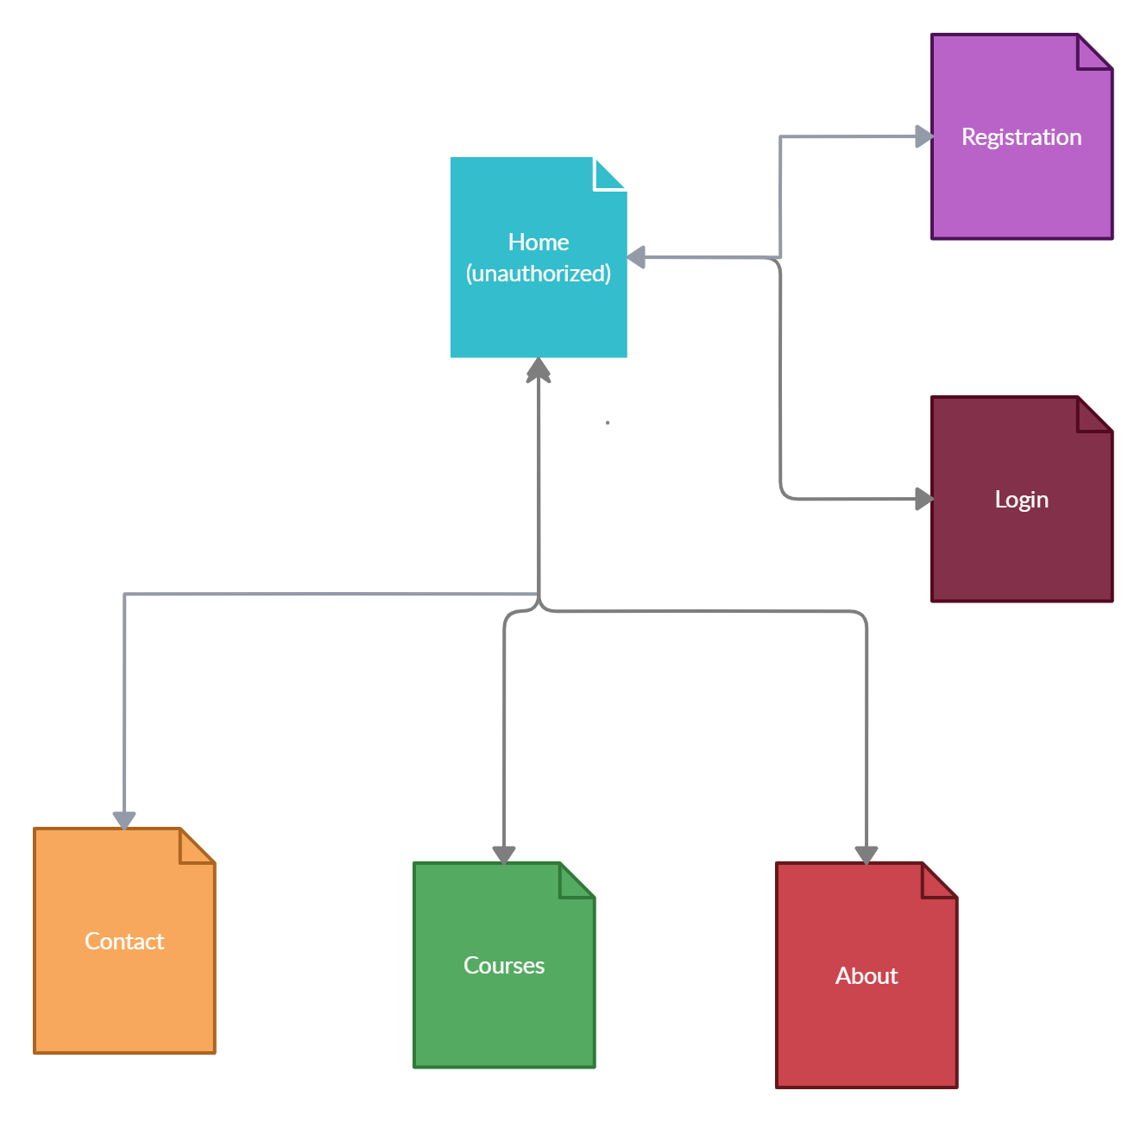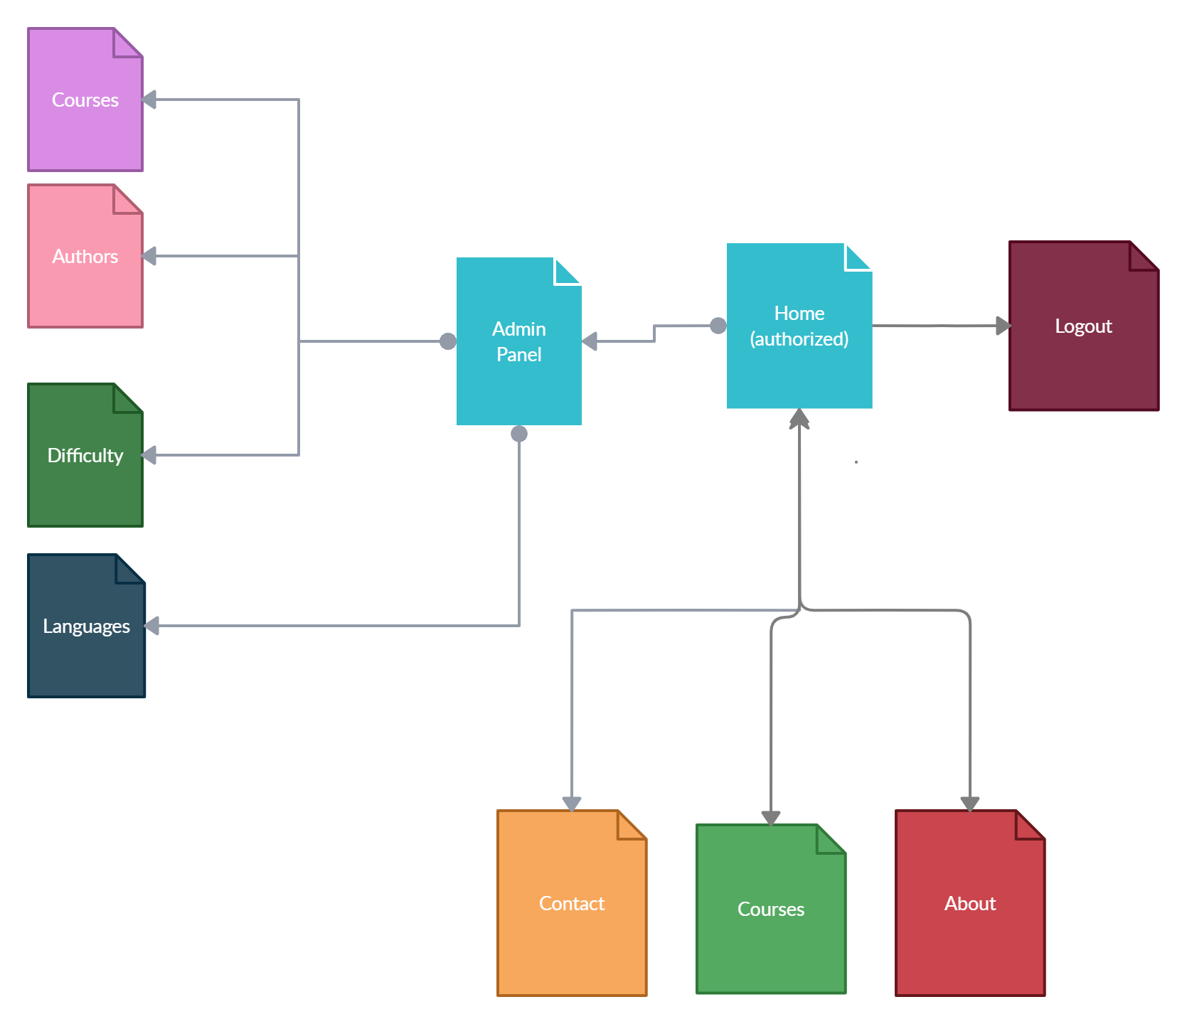

## **Mapa sajta**

<?xml version="1.0" encoding="UTF-8"?>

<urlset

      xmlns="http://www.sitemaps.org/schemas/sitemap/0.9"

      xmlns:xsi="http://www.w3.org/2001/XMLSchema-instance"

      xsi:schemaLocation="http://www.sitemaps.org/schemas/sitemap/0.9

            http://www.sitemaps.org/schemas/sitemap/0.9/sitemap.xsd">

<url>

  <loc>https://code-freakz.herokuapp.com/</loc>

  <lastmod>2020-03-18</lastmod>

  <priority>1.00</priority>

  <changefreq>daily</changefreq>

</url>

<url>

  <loc>https://code-freakz.herokuapp.com/courses</loc>

  <lastmod>2020-03-18</lastmod>

  <priority>0.90</priority>

  <changefreq>daily</changefreq>

</url>

<url>

  <loc>https://code-freakz.herokuapp.com/contact</loc>

  <lastmod>2020-03-18</lastmod>

  <priority>0.90</priority>

  <changefreq>monthly</changefreq>

</url>

<url>

  <loc>https://code-freakz.herokuapp.com/about</loc>

  <lastmod>2019-02-18</lastmod>

  <priority>0.70</priority>

  <changefreq>yearly</changefreq>

</url>

<url>

  <loc>https://code-freakz.herokuapp.com/login</loc>

  <lastmod>2019-03-18</lastmod>

  <priority>0.50</priority>

  <changefreq>yearly</changefreq>

</url>

<url>

  <loc>https://code-freakz.herokuapp.com/register</loc>

  <lastmod>2019-03-18</lastmod>

  <priority>0.50</priority>

  <changefreq>yearly</changefreq>

</url>

</urlset>

## **Opis stranica sajta**

### Home



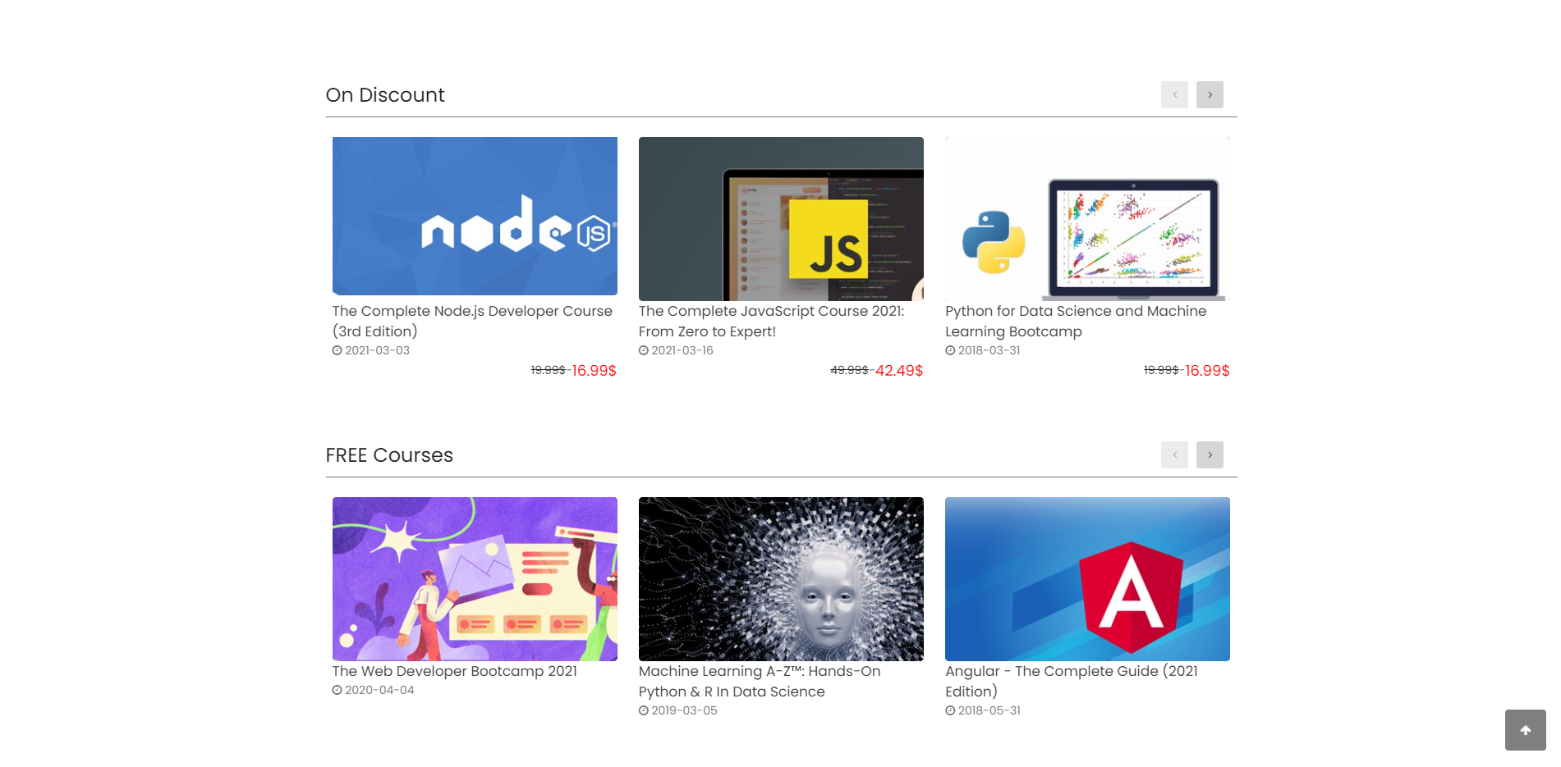

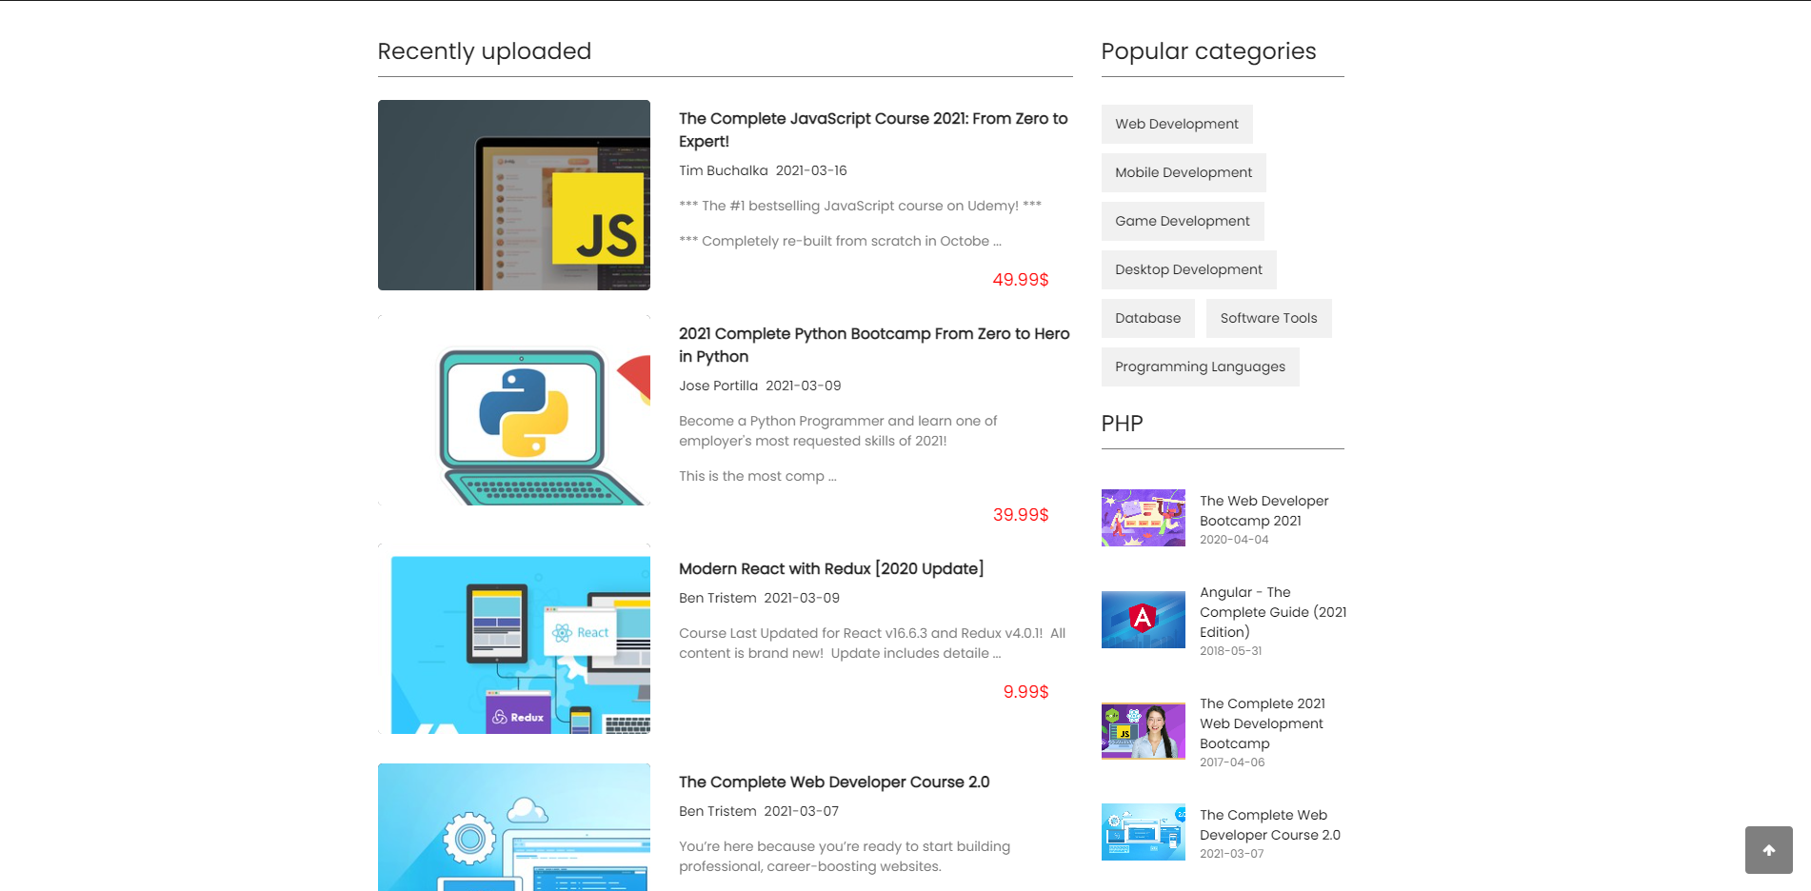

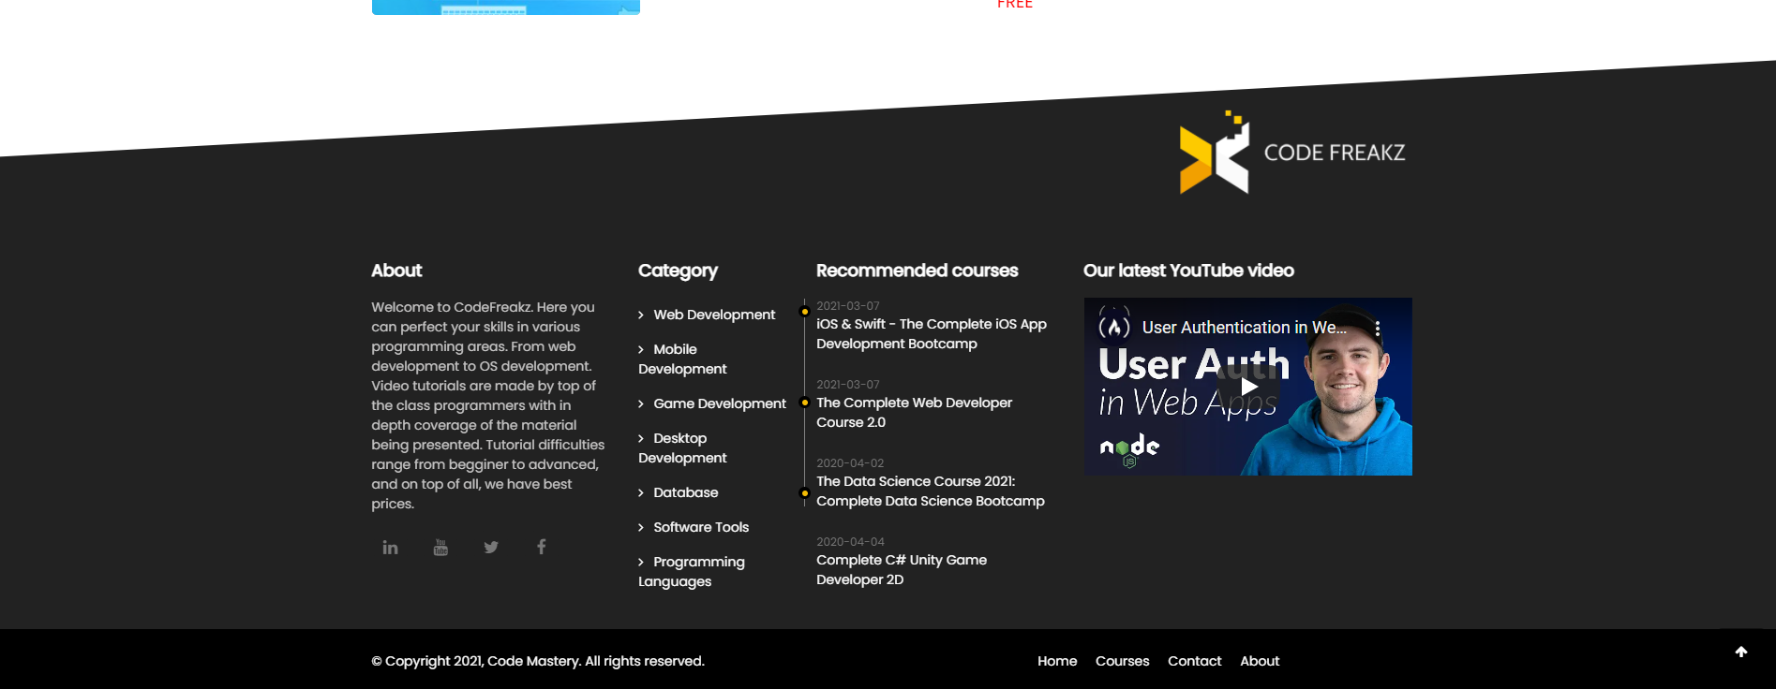

Na pocetnoj stranici se nalaze sekcije za prikaz preporucenih kurseva, besplatnih, na popustu, skoro izbacenih kao i kursevi random jezika.

### Courses

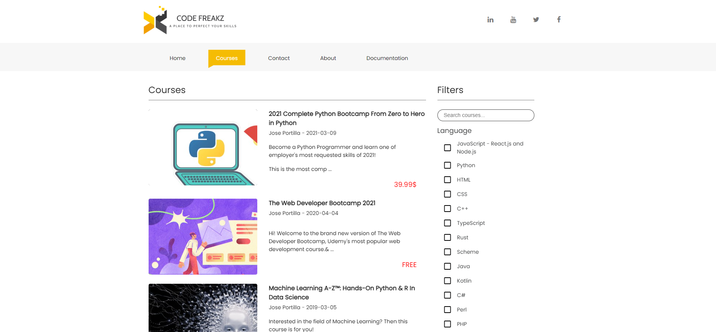

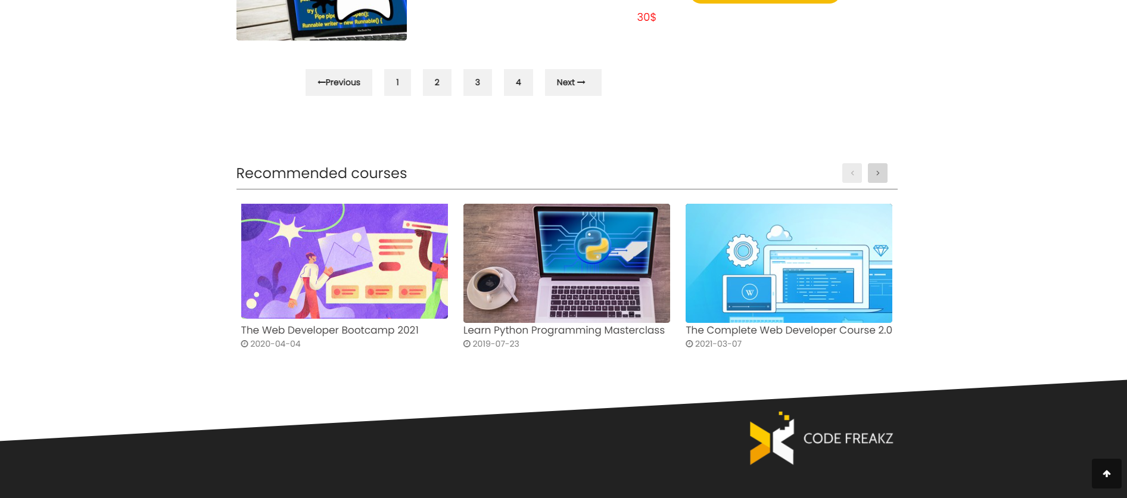

Na stranici za kurseve se nalazi lista kurseva kao i filter opcije.

Odmah ispod se nalaze sekcija za preporucene kurseve.

### Contact

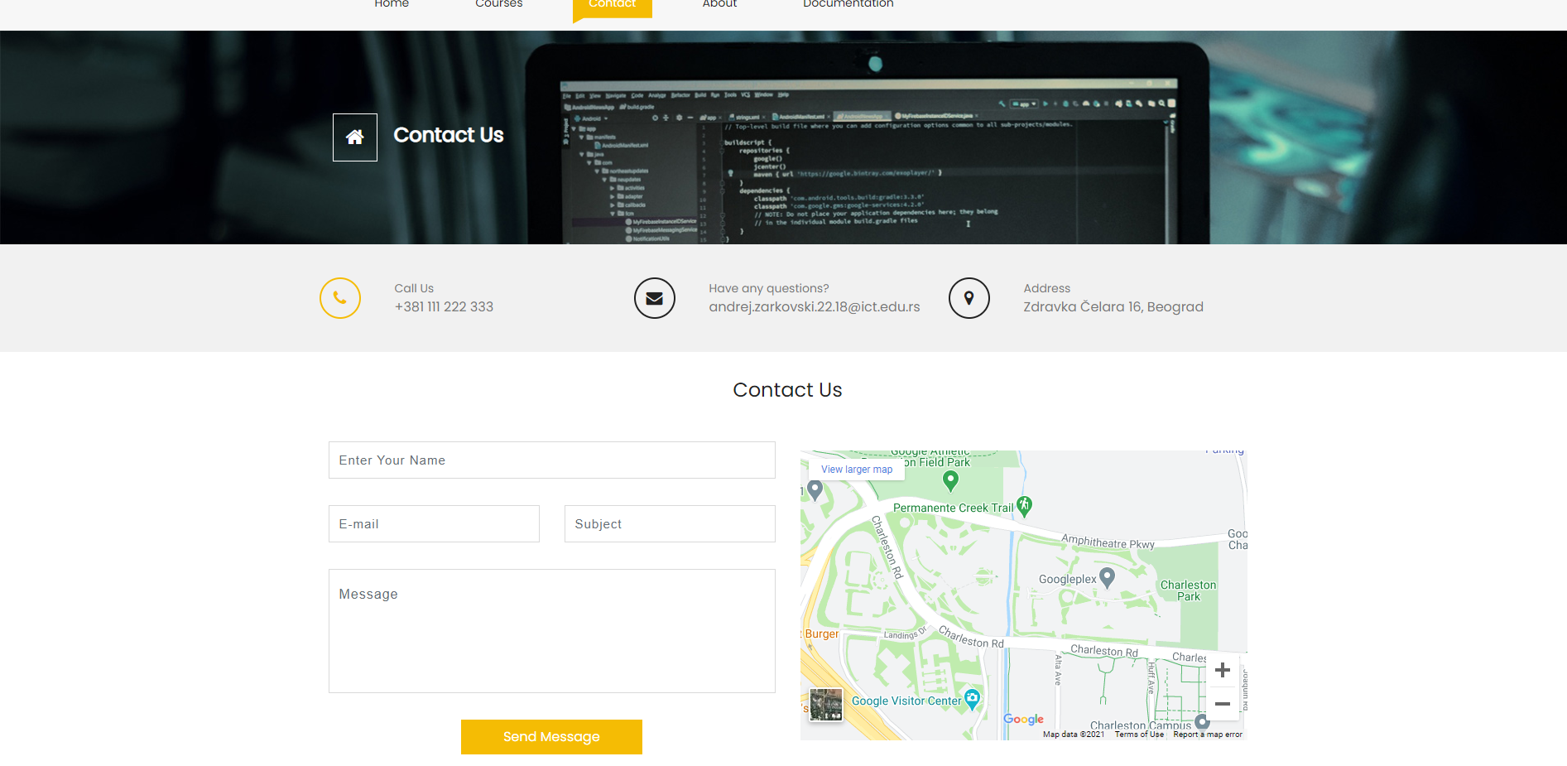

Kontakt stranica za kontaktiranje administratora sajta.

### About

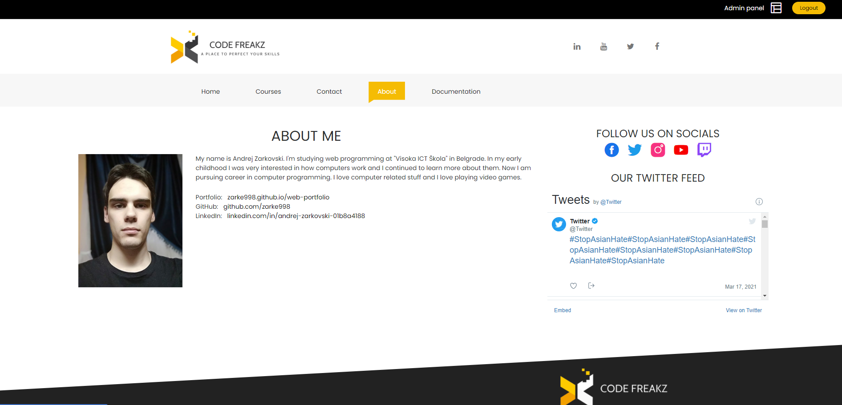

Stranica o autoru.

### Login

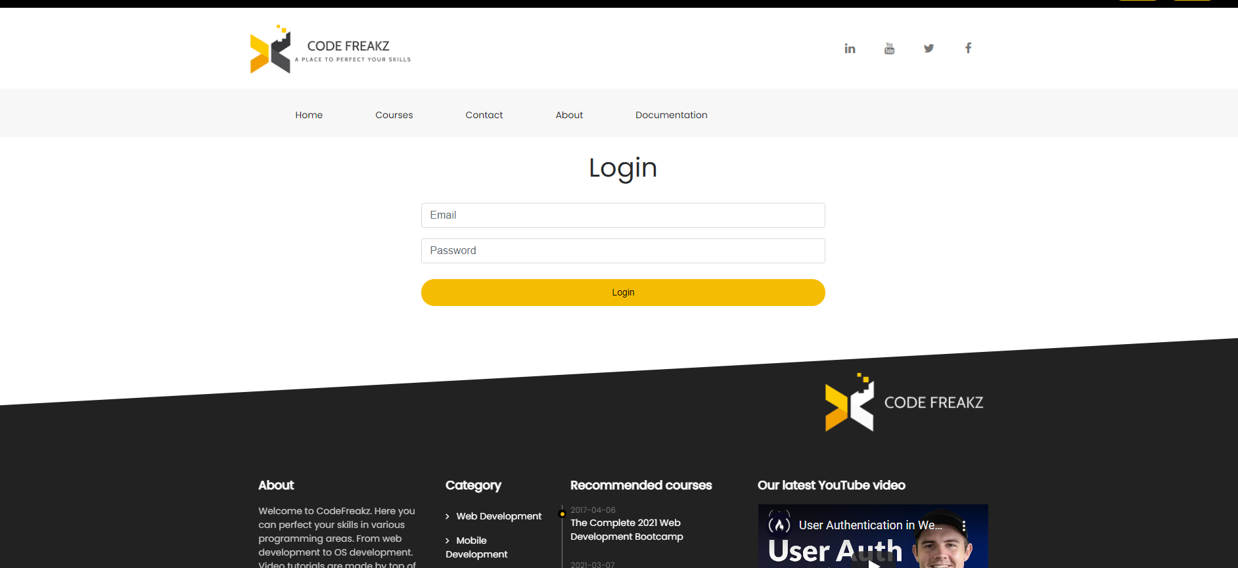

Stranica za logovanje.

### Register

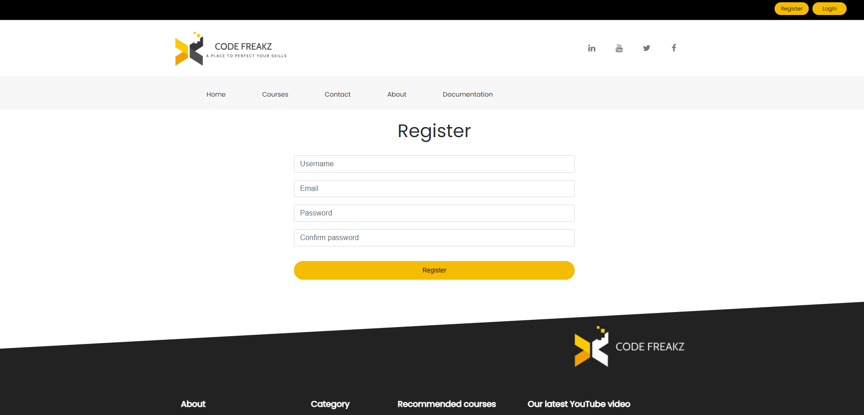Stranica za registraciju.

### 403

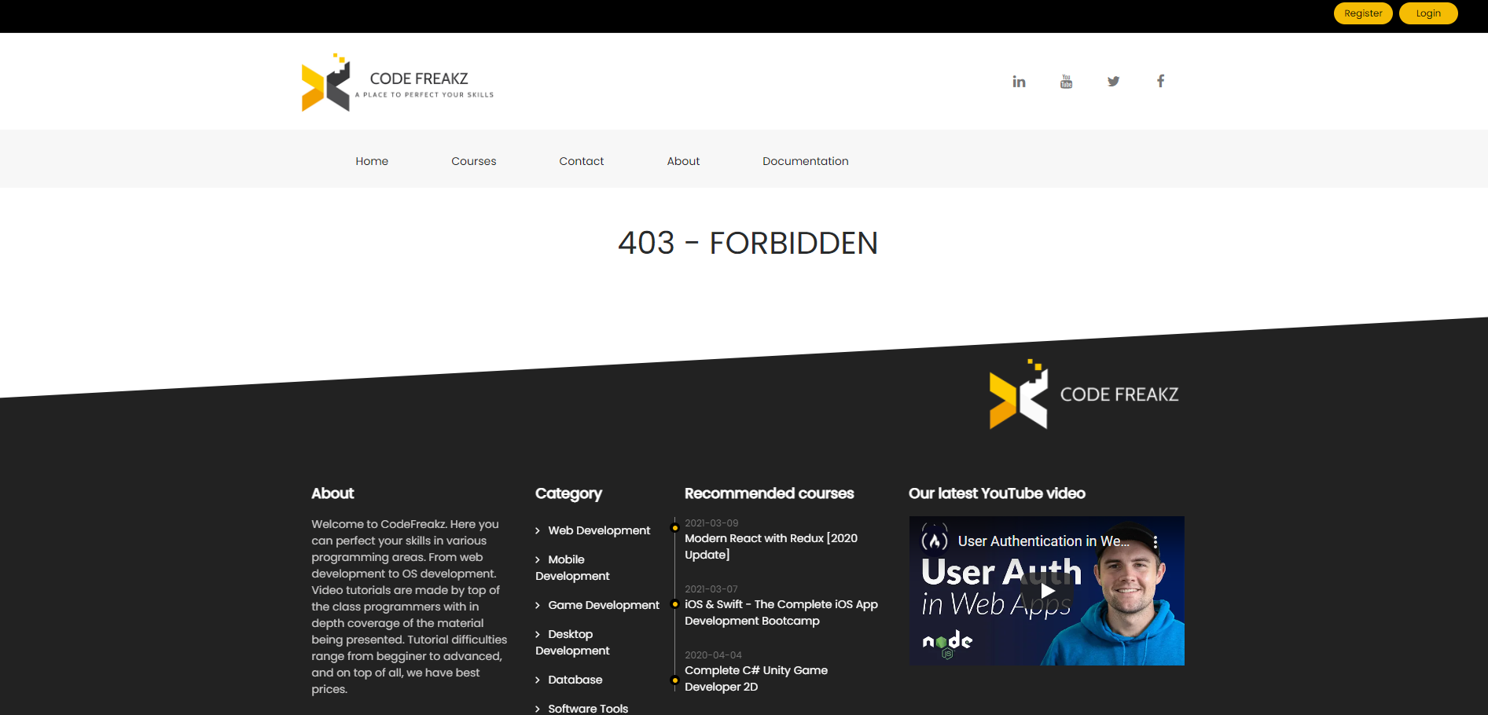

### Admin/content/courses

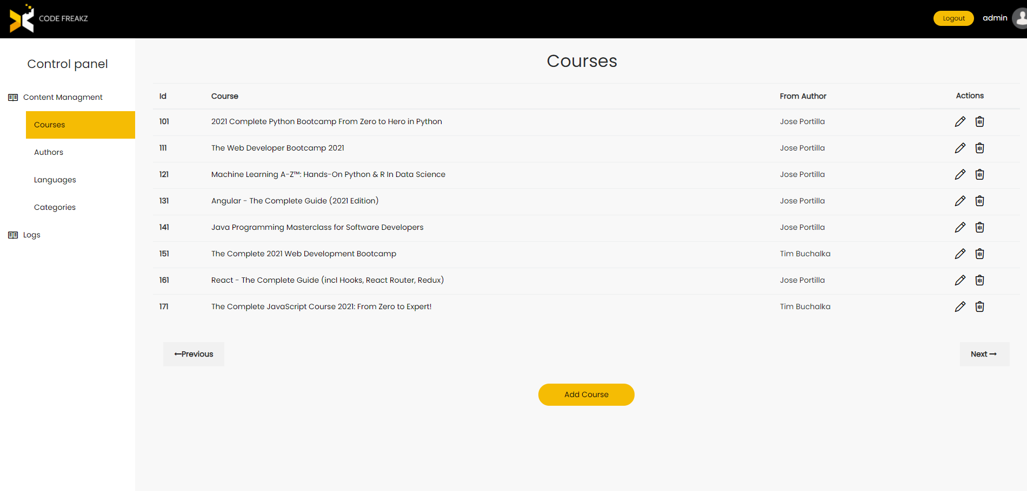

Admin panel stranica sa listom kurseva.

Ostale stranice admin panela su u istom formatu kao i stranica za kurseve.

### Course/create

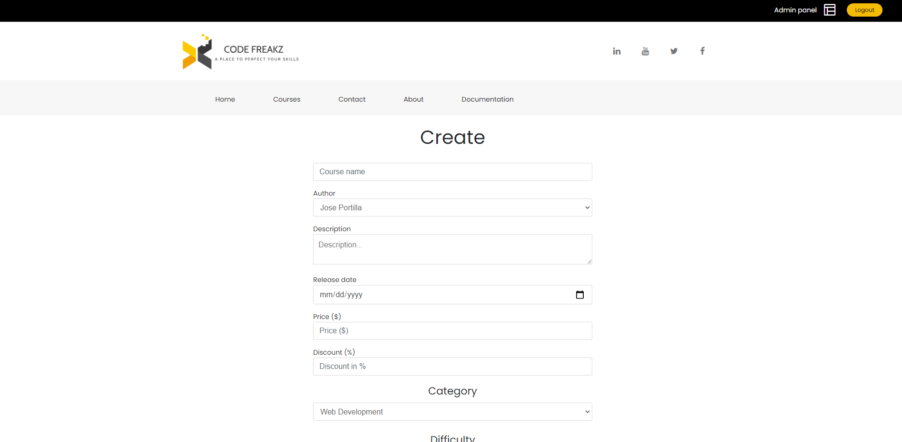

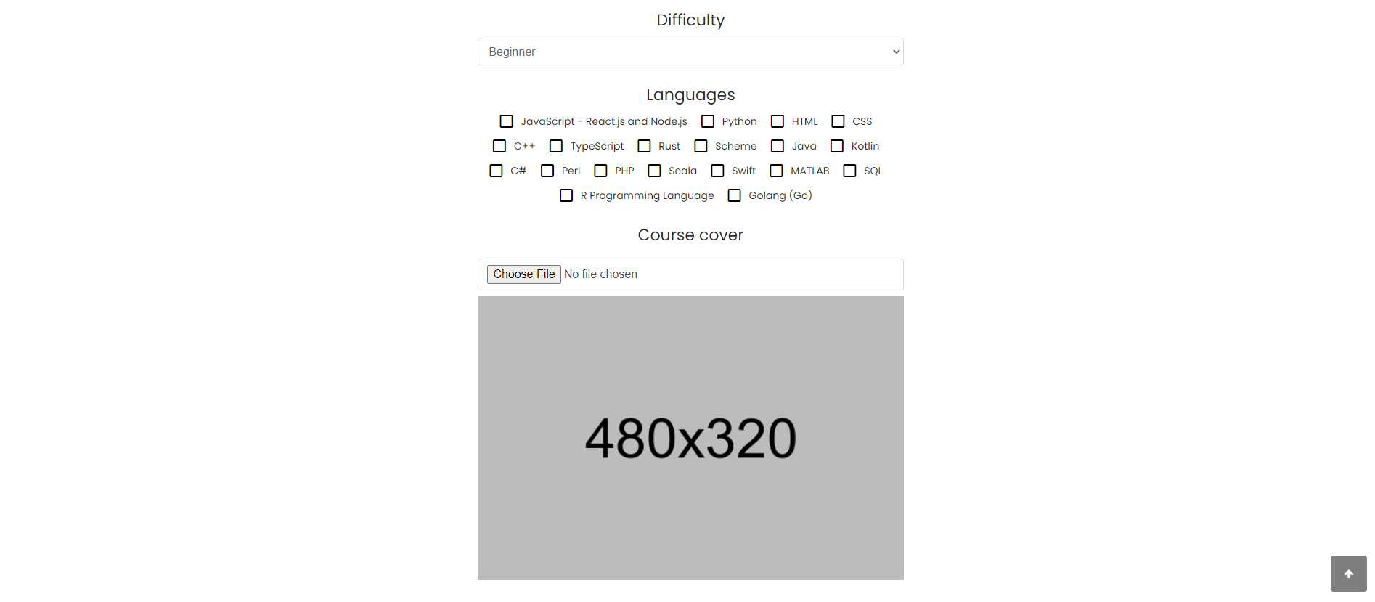

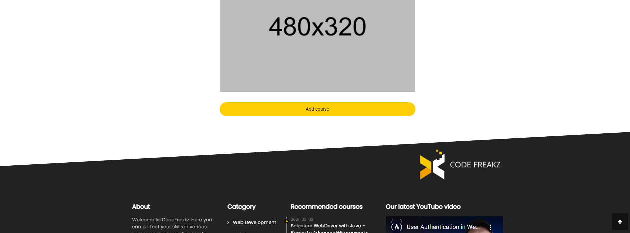

Stranica za kreiranje kursa.

Isti format se koristi i za stranicu za izmenu kursa, kao i za stranice za autora, jezik itd.

### Course/details

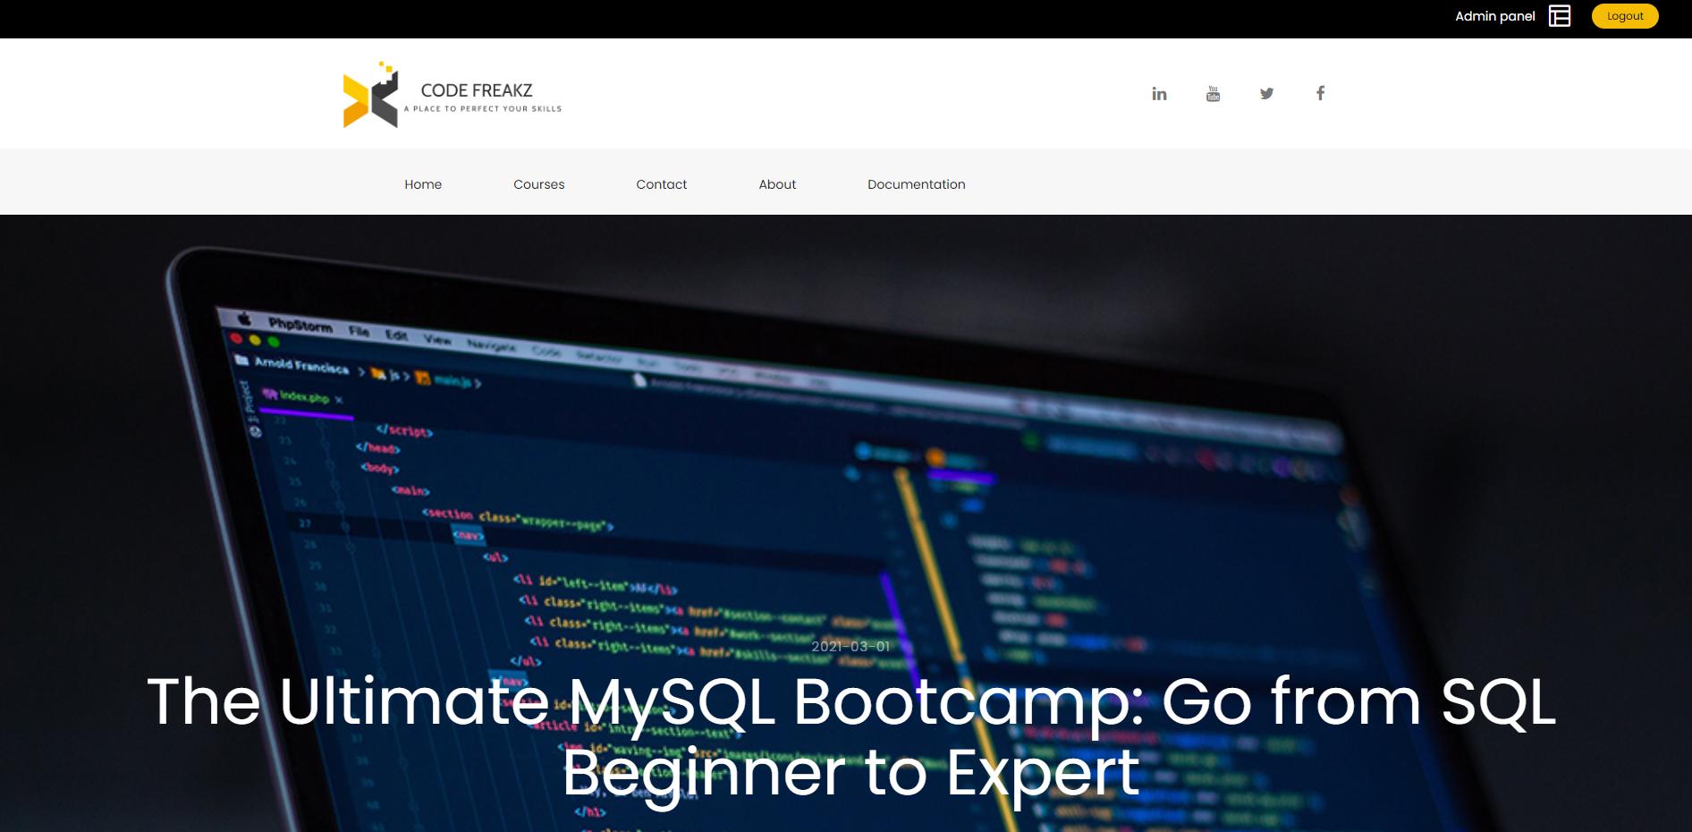

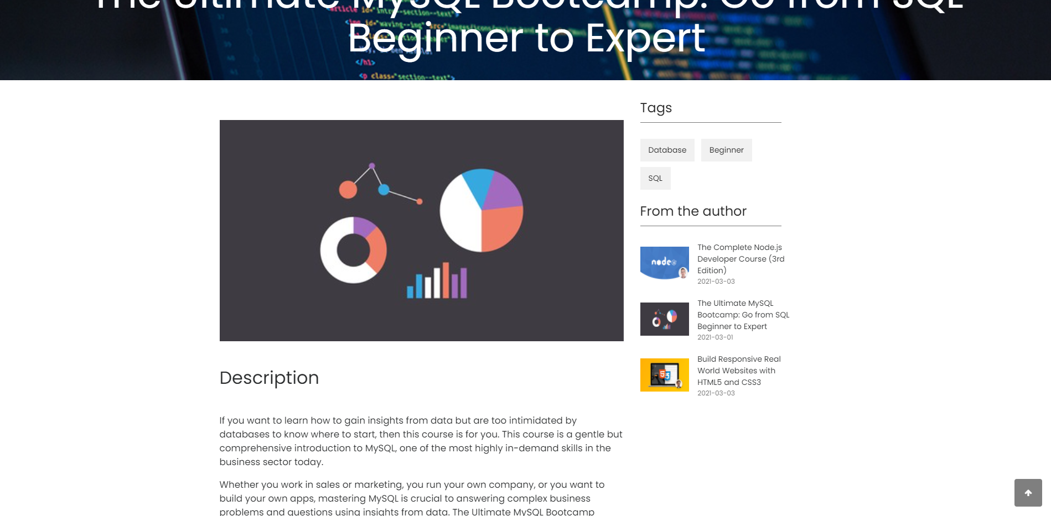

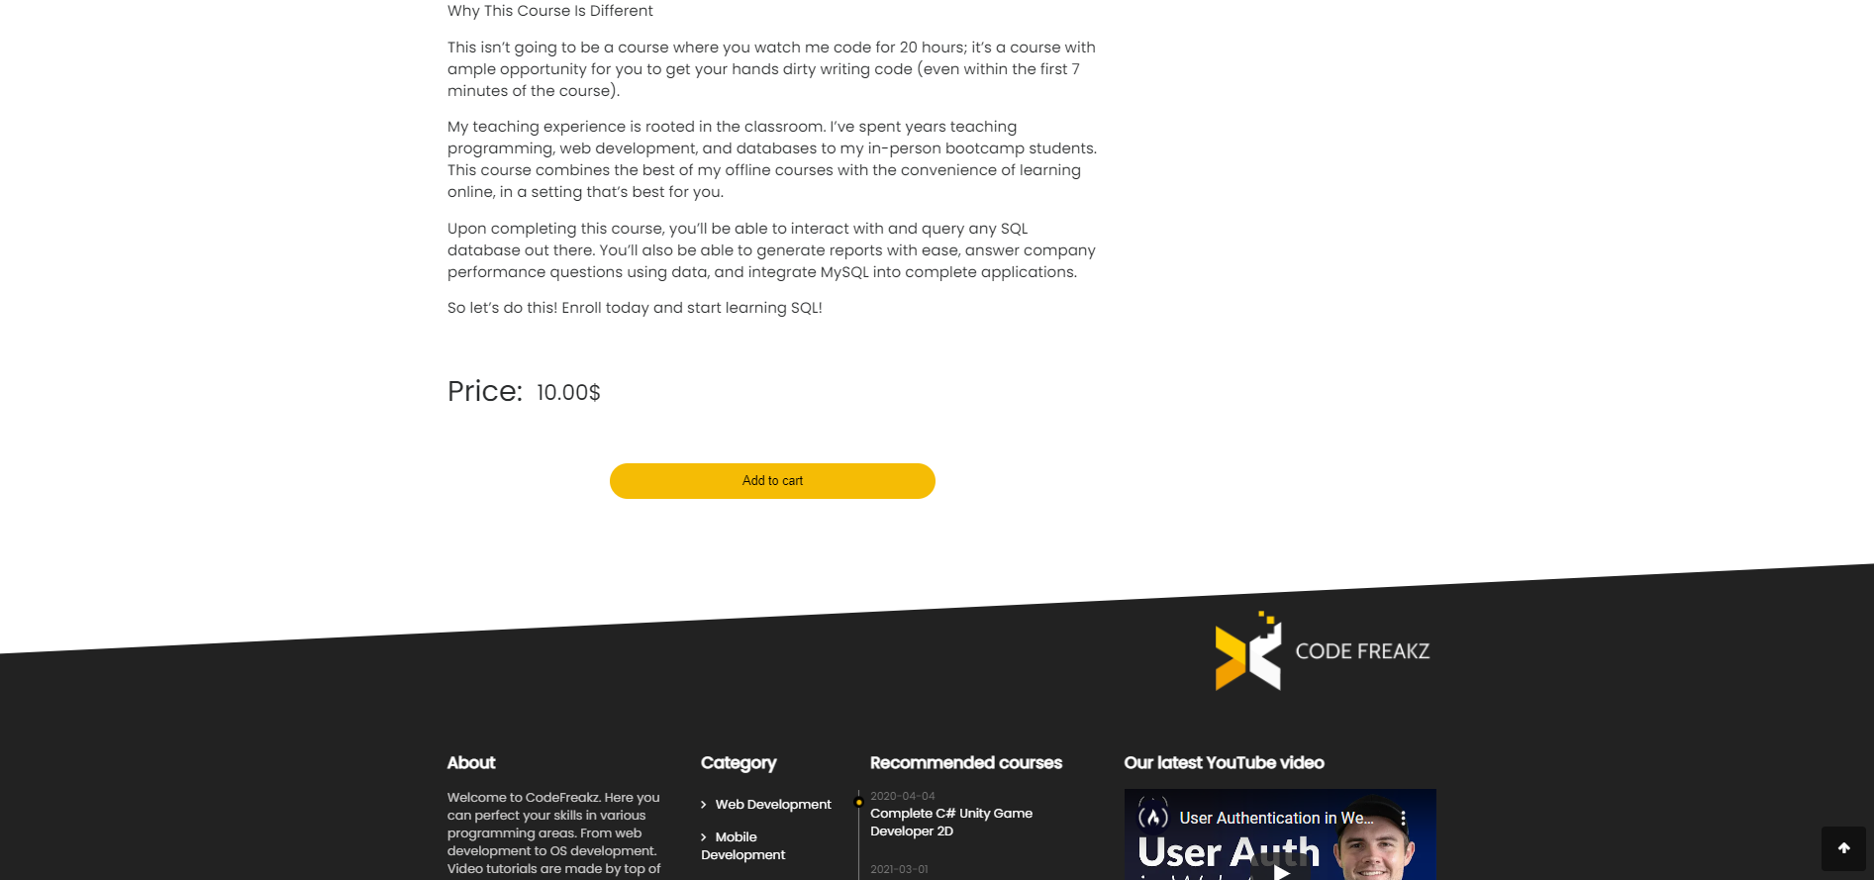

Stranica o detaljima kursa.

# 3. Kodovi

## Fajl ogranizacija

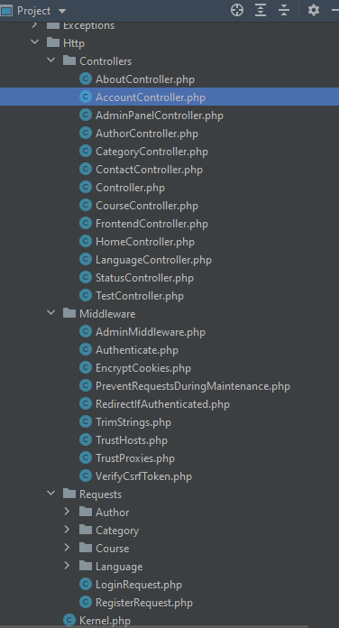

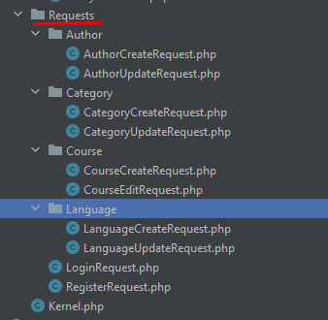

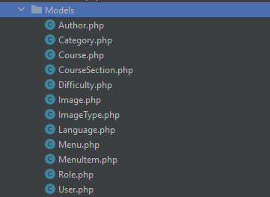

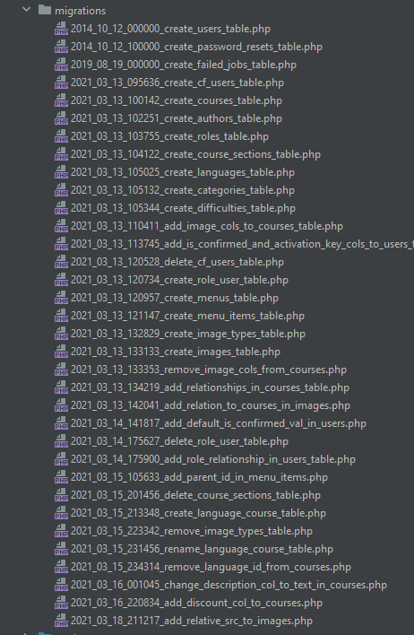

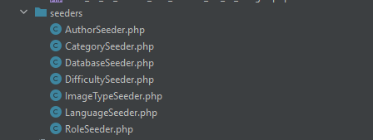

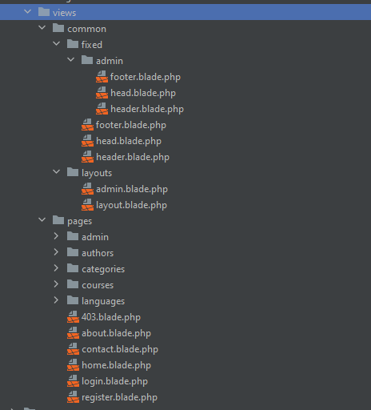

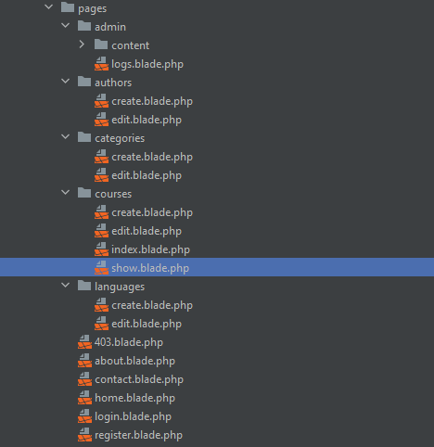

## Controllers

### AboutController

<?php  
  
namespace App\Http\Controllers;  
  
use Illuminate\Http\Request;  
  
class AboutController extends FrontendController  
{  
 public function index(){  
 return view("pages.about", $this->data);  
 }  
}

### AccountController

<?php  
  
namespace App\Http\Controllers;  
  
use App\Http\Requests\RegisterRequest;  
use App\Http\Requests\LoginRequest;  
use Illuminate\Http\Request;  
use App\Models\User;  
use App\Models\Role;  
  
class AccountController extends FrontendController  
{  
 public function loginPage(){  
 return view("pages.login", $this->data);  
 }  
 public function login(LoginRequest $request){  
 $user = User::*with*("role")->where("email", "=", $request->email)->first();  
  
 if(!password_verify($request->password, $user->password)){  
 return redirect()->route("loginPage")->with("loginErrorMsg", "Password incorrect.")->withInput();  
 }  
 else{  
 session()->put("user", $user);  
 return redirect()->route("home");  
 }  
 }  
 public function registerPage(){  
 return view("pages.register", $this->data);  
 }  
 public function register(RegisterRequest $request){  
 $user = new User($request->except("password"));  
 $user->password = password_hash($request->password, *PASSWORD_DEFAULT*);  
 $user->activation_key = $this->generateActivationKey(64);  
  
 $userRoleId = Role::*all*()->where("name","=","user")->first()->id;  
 $user->role_id = $userRoleId;  
  
 $user->save();  
  
 return redirect()->route("loginPage")->with("registrationSuccessfullMsg", "Registration successfull.");  
 }  
  
 public function logout(){  
 session()->remove("user");  
 return redirect()->route("home");  
 }  
  
 private function generateActivationKey($length){  
 $chars = '0123456789abcdefghijklmnopqrstuvwxyzABCDEFGHIJKLMNOPQRSTUVWXYZ';  
  
 $key = "";  
  
 for($i = 0; $i < $length; $i++){  
 $key.= $chars[rand(0, strlen($chars) - 1)];  
 }  
  
 return $key;  
 }  
}

### AdminController

<?php  
  
namespace App\Http\Controllers;  
  
use App\Models\Author;  
use App\Models\Category;  
use App\Models\Course;  
use App\Models\Language;  
use App\Models\Menu;  
use App\Models\MenuItem;  
use Illuminate\Http\Request;  
  
class AdminPanelController extends Controller  
{  
 private $data = [];  
  
 public function __construct()  
 {  
 $menu = Menu::*with*("items")->where("name","=","admin_panel")->first();  
 $menuGrouped = $this->groupMenuItemsByParent($menu->items);  
  
 $this->data["menu_grouped"] = $menuGrouped;  
 }  
  
 public function coursesPage(){  
 $courses = Course::*with*("author")->simplePaginate(8);  
 $this->data["courses"] = $courses;  
  
 return view("pages.admin.content.courses", $this->data);  
 }  
  
 public function authorsPage(){  
 $authors = Author::*all*();  
 $this->data["authors"] = $authors;  
  
 return view("pages.admin.content.authors", $this->data);  
 }  
 public function languagesPage(){  
 $languages = Language::*all*();  
 $this->data["languages"] = $languages;  
  
 return view("pages.admin.content.languages", $this->data);  
 }  
 public function categoriesPage(){  
 $categories = Category::*all*();  
 $this->data["categories"] = $categories;  
  
 return view("pages.admin.content.categories", $this->data);  
 }  
  
 public function logsPage(){  
 return view("pages.admin.logs");  
 }  
  
 private function groupMenuItemsByParent($menu_items){  
 $menu_grouped = [];  
 foreach($menu_items as $item){  
 if($item->parent_id == null){  
 $menu_grouped[$item->name] = [];  
 array_unshift($menu_grouped[$item->name], $item);  
 continue;  
 }  
 $parent_name = array_filter($menu_items->toArray(), function($val) use($item){  
 return $val["id"] == $item["parent_id"];  
 })[0]["name"];  
  
 array_push($menu_grouped[$parent_name], $item);  
 }  
 return $menu_grouped;  
 }  
}

### AuthorController

<?php  
  
namespace App\Http\Controllers;  
  
use App\Models\Author;  
use Illuminate\Database\QueryException;  
use Illuminate\Http\Request;  
  
class AuthorController extends FrontendController  
{  
 */**  
 * Display a listing of the resource.  
 *  
 \** ***@return*** *\Illuminate\Http\Response  
 */* public function index()  
 {  
 //  
 }  
  
 */**  
 * Show the form for creating a new resource.  
 *  
 \** ***@return*** *\Illuminate\Http\Response  
 */* public function create()  
 {  
 return view("pages.authors.create", $this->data);  
 }  
  
 */**  
 * Store a newly created resource in storage.  
 *  
 \** ***@param*** *\Illuminate\Http\Request $request  
 \** ***@return*** *\Illuminate\Http\Response  
 */* public function store(Request $request)  
 {  
 Author::*create*($request->except("_token"));  
  
 return redirect()->route("admin.authorsPage")->with("authorCreateMsg", "Author created successfully");  
 }  
  
 */**  
 * Display the specified resource.  
 *  
 \** ***@param*** *int $id  
 \** ***@return*** *\Illuminate\Http\Response  
 */* public function show($id)  
 {  
 //  
 }  
  
 */**  
 * Show the form for editing the specified resource.  
 *  
 \** ***@param*** *int $id  
 \** ***@return*** *\Illuminate\Http\Response  
 */* public function edit($id)  
 {  
 $author = Author::*find*($id);  
 $this->data["author"] = $author;  
 return view("pages.authors.edit",$this->data);  
 }  
  
 */**  
 * Update the specified resource in storage.  
 *  
 \** ***@param*** *\Illuminate\Http\Request $request  
 \** ***@param*** *int $id  
 \** ***@return*** *\Illuminate\Http\Response  
 */* public function update(Request $request, $id)  
 {  
 $author = Author::*find*($id);  
 $author->fill($request->except("_token"));  
  
 $author->save();  
  
 return redirect()->route("admin.authorsPage")->with(["entityCreateMsg" => "Author updated successfully"]);  
 }  
  
 */**  
 * Remove the specified resource from storage.  
 *  
 \** ***@param*** *int $id  
 \** ***@return*** *\Illuminate\Http\Response  
 */* public function destroy($id)  
 {  
 try{  
 Author::*destroy*($id);  
 return redirect()->back();  
 }  
 catch (QueryException $e){  
 return redirect()->back()->with(["entityErrorMsg" => "Error deleting author. Please delete all correlated courses first."]);  
 }  
 }  
}

### CategoryController

<?php  
  
namespace App\Http\Controllers;  
  
use App\Http\Requests\Category\CategoryCreateRequest;  
use App\Http\Requests\Category\CategoryUpdateRequest;  
use App\Models\Category;  
use Illuminate\Database\QueryException;  
use Illuminate\Http\Request;  
  
class CategoryController extends FrontendController  
{  
  
 */**  
 * Display a listing of the resource.  
 *  
 \** ***@return*** *\Illuminate\Http\Response  
 */* public function index()  
 {  
 //  
 }  
  
 */**  
 * Show the form for creating a new resource.  
 *  
 \** ***@return*** *\Illuminate\Http\Response  
 */* public function create()  
 {  
 return view("pages.categories.create", $this->data);  
 }  
  
 */**  
 * Store a newly created resource in storage.  
 *  
 \** ***@param*** *\Illuminate\Http\Request $request  
 \** ***@return*** *\Illuminate\Http\Response  
 */* public function store(CategoryCreateRequest $request)  
 {  
 Category::*create*($request->except("_token"));  
  
 return redirect()->route("admin.categoriesPage")->with("entityCreateMsg", "Category created successfully.");  
 }  
  
 */**  
 * Display the specified resource.  
 *  
 \** ***@param*** *int $id  
 \** ***@return*** *\Illuminate\Http\Response  
 */* public function show($id)  
 {  
 //  
 }  
  
 */**  
 * Show the form for editing the specified resource.  
 *  
 \** ***@param*** *int $id  
 \** ***@return*** *\Illuminate\Http\Response  
 */* public function edit($id)  
 {  
 $category = Category::*find*($id);  
  
 $this->data["category"] = $category;  
  
 return view("pages.categories.edit", $this->data);  
 }  
  
 */**  
 * Update the specified resource in storage.  
 *  
 \** ***@param*** *\Illuminate\Http\Request $request  
 \** ***@param*** *int $id  
 \** ***@return*** *\Illuminate\Http\Response  
 */* public function update(CategoryUpdateRequest $request, $id)  
 {  
 $category = Category::*find*($id);  
  
 $category->fill($request->except("_token"));  
  
 $category->save();  
  
 return redirect()->route("admin.categoriesPage")->with("entityCreateMsg", "Category updated successfully.");  
 }  
  
 */**  
 * Remove the specified resource from storage.  
 *  
 \** ***@param*** *int $id  
 \** ***@return*** *\Illuminate\Http\Response  
 */* public function destroy($id)  
 {  
 try{  
 Category::*destroy*($id);  
  
 return redirect()->back();  
 }  
 catch (QueryException $exception){  
 return redirect()->back()->with(["entityErrorMsg" => "Error category language. Please delete courses which have this category first."]);  
 }  
 }  
}

### ContactController

<?php  
  
namespace App\Http\Controllers;  
  
use Illuminate\Http\Request;  
  
class ContactController extends FrontendController  
{  
 public function index(){  
 return view("pages.contact", $this->data);  
 }  
}

### CourseController

<?php  
  
namespace App\Http\Controllers;  
  
use App\Http\Requests\Course\CourseCreateRequest;  
use App\Models\Author;  
use App\Models\Category;  
use App\Models\Course;  
use App\Models\Difficulty;  
use App\Models\Image;  
use App\Models\Language;  
use http\Env\Response;  
use Illuminate\Http\Request;  
use Illuminate\Support\Facades\Storage;  
use SebastianBergmann\Diff\Diff;  
  
class CourseController extends FrontendController  
{  
 */**  
 * Display a listing of the resource.  
 *  
 \** ***@return*** *\Illuminate\Http\Response  
 */* public function index()  
 {  
 $languages = Language::*all*();  
 $categories = Category::*all*();  
 $difficulties = Difficulty::*all*();  
 $recommended_courses = Course::*recommendedCourses*();  
  
 $this->data["languages"] = $languages;  
 $this->data["categories"] = $categories;  
 $this->data["difficulties"] = $difficulties;  
 $this->data["recommended_courses"] = $recommended_courses;  
  
  
 return view("pages.courses.index", $this->data);  
 }  
  
 */**  
 * Show the form for creating a new resource.  
 *  
 \** ***@return*** *\Illuminate\Http\Response  
 */* public function create()  
 {  
 $this->data["authors"] = Author::*all*();  
 $this->data["categories"] = Category::*all*();  
 $this->data["difficulties"] = Difficulty::*all*();  
 $this->data["languages"] = Language::*all*();  
  
 return view("pages.courses.create", $this->data);  
 }  
  
 */**  
 * Store a newly created resource in storage.  
 *  
 \** ***@param*** *\Illuminate\Http\Request $request  
 \** ***@return*** *\Illuminate\Http\Response  
 */* public function store(CourseCreateRequest $request)  
 {  
 $course = new Course($request->except(["_token", "image","language_id"]));  
 $course->save();  
  
 $course->languages()->sync($request->input("language_id"));  
  
 //Save image  
// $new_image_name = md5($request->file("image")->getFilename()) . time() . "." . $request->file("image")->extension();  
  
 $base_url = "https://code-freakz.s3.eu-central-1.amazonaws.com/";  
 $relative_src = Storage::disk("s3")->put("public/images", $request->file("image"), "public");  
 $src = Storage::disk("s3")->url($relative_src);  
  
 Image::*create*(["src" => $src, "relative_src" => $relative_src, "course_id" => $course->id]);  
  
 return redirect()->route("admin.coursesPage")->with("entityInsertMsg", "Course added successfully.");  
 }  
  
 */**  
 * Display the specified resource.  
 *  
 \** ***@param*** *int $id  
 \** ***@return*** *\Illuminate\Http\Response  
 */* public function show($id)  
 {  
 $course = Course::*find*($id);  
  
 $this->data["course"] = $course;  
 return view("pages.courses.show", $this->data);  
 }  
  
 */**  
 * Show the form for editing the specified resource.  
 *  
 \** ***@param*** *int $id  
 \** ***@return*** *\Illuminate\Http\Response  
 */* public function edit($id)  
 {  
 $course = Course::*with*("images")->where("id", "=", $id)->first();  
 $this->data["authors"] = Author::*all*();  
 $this->data["categories"] = Category::*all*();  
 $this->data["difficulties"] = Difficulty::*all*();  
 $this->data["languages"] = Language::*all*();  
  
 $this->data["course"] = $course;  
  
 return view("pages.courses.edit", $this->data);  
 }  
  
 */**  
 * Update the specified resource in storage.  
 *  
 \** ***@param*** *\Illuminate\Http\Request $request  
 \** ***@param*** *int $id  
 \** ***@return*** *\Illuminate\Http\Response  
 */* public function update(Request $request, $id)  
 {  
 $course = Course::*find*($id);  
 $course->fill($request->except(["_token", "language_id", "image"]));  
  
 $course->save();  
  
 $course->languages()->sync($request->input("language_id"));  
  
 if($request->has("image")){  
 Storage::disk("s3")->delete($course->images[0]->relative_src);  
 Image::*where*("course_id","=", $course->id)->delete();  
  
 $relative_src = Storage::disk("s3")->put("public/images", $request->file("image"),"public");  
 $src = Storage::disk("s3")->url($relative_src);  
 Image::*create*(["src" => $src, "relative_src" => $relative_src,"course_id" => $course->id]);  
 }  
  
 return redirect()->route("admin.coursesPage")->with("entityInsertMsg", "Course updated successfully.");  
 }  
  
 */**  
 * Remove the specified resource from storage.  
 *  
 \** ***@param*** *int $id  
 \** ***@return*** *\Illuminate\Http\Response  
 */* public function destroy($id)  
 {  
 $course = Course::*find*($id);  
  
 $course->languages()->sync([]);  
  
 Storage::disk("s3")->delete($course->images[0]->relative_src);  
 Image::*where*("course_id","=", $course->id)->delete();  
  
 $course->delete();  
  
 return response()->json(["msg" => "Course deleted successfully"]);  
 }  
  
 public function paginate(Request $request){  
 $per_page = 8;  
 $offset = 0;  
  
 $courses = Course::*with*("images")->with("author");  
  
 $data = [];  
  
 //FILTERS  
 if($request->has("search")){  
 $courses = $courses->where("courses.name", "LIKE", "%".$request->input("search")."%");  
 }  
 if($request->has("languages")){  
 $courses = $courses->whereHas("languages", function($l) use ($request){  
 $l->whereIn("languages.id", $request->input("languages"));  
 });  
 }  
 if($request->has("category")){  
 $courses = $courses->where("category_id", "=", $request->input("category"));  
 }  
 if($request->has("difficulty")){  
 $courses = $courses->where("difficulty_id", "=", $request->input("difficulty"));  
 }  
 $filtered_count = $courses->count();  
  
  
 // LIMIT AND OFFSET  
 if($request->has("per_page"))  
 $per_page = $request->input("per_page");  
  
 if($request->has("offset"))  
 $offset = $request->input("offset");  
  
 $courses = $courses->skip($offset)->take($per_page)->get();  
  
 //Courses count is used in admin panel - courses page  
 $courses_count = Course::*all*()->count();  
 $data["courses_count"] = $courses_count;  
 $data["filtered_count"] = $filtered_count;  
  
 $data["courses"] = $courses;  
  
 return response()->json($data);  
 }  
}

### FrontendController

<?php  
  
namespace App\Http\Controllers;  
  
use App\Models\Category;  
use App\Models\Course;  
use App\Models\Menu;  
use Illuminate\Http\Request;  
  
class FrontendController extends Controller  
{  
 protected $data = [];  
  
 public function __construct()  
 {  
 $menu = Menu::*with*("items")->where("name","=","header_menu")->first();  
 $this->data["header_menu"] = $menu->items;  
 $this->data["footer_categories"] = Category::*topEightCategories*();  
 $this->data["footer_courses"] = Course::*recommendedCourses*()->take(4);  
 }  
}

### HomeController

<?php  
  
namespace App\Http\Controllers;  
  
use App\Models\Category;  
use App\Models\Course;  
use App\Models\Language;  
use Illuminate\Http\Request;  
  
class HomeController extends FrontendController  
{  
 public function index(){  
 $recommended_courses = Course::*recommendedCourses*();  
 $discounted_courses = Course::*topFiveDiscounted*();  
 $free_courses = Course::*topFiveFree*();  
 $recent_courses = Course::*recentlyReleased*();  
 $categories = Category::*topEightCategories*();  
 $rand_lang = Language::*randLangWithCourses*();  
  
 $this->data["recommended_courses"] = $recommended_courses;  
 $this->data["discounted_courses"] = $discounted_courses;  
 $this->data["free_courses"] = $free_courses;  
 $this->data["recent_courses"] = $recent_courses;  
 $this->data["categories"] = $categories;  
 $this->data["rand_lang"] = $rand_lang;  
  
 return view("pages.home", $this->data);  
 }  
}

### LanguageController

<?php  
  
namespace App\Http\Controllers;  
  
use App\Http\Requests\Language\LanguageCreateRequest;  
use App\Http\Requests\Language\LanguageUpdateRequest;  
use App\Models\Language;  
use Illuminate\Database\QueryException;  
use Illuminate\Http\Request;  
  
class LanguageController extends FrontendController  
{  
 */**  
 * Display a listing of the resource.  
 *  
 \** ***@return*** *\Illuminate\Http\Response  
 */* public function index()  
 {  
  
 }  
  
 */**  
 * Show the form for creating a new resource.  
 *  
 \** ***@return*** *\Illuminate\Http\Response  
 */* public function create()  
 {  
 return view("pages.languages.create", $this->data);  
 }  
  
 */**  
 * Store a newly created resource in storage.  
 *  
 \** ***@param*** *\Illuminate\Http\Request $request  
 \** ***@return*** *\Illuminate\Http\Response  
 */* public function store(LanguageCreateRequest $request)  
 {  
 Language::*create*($request->except("_token"));  
  
 return redirect()->route("admin.languagesPage")->with("entityCreateMsg", "Language created successfully.");  
 }  
  
 */**  
 * Display the specified resource.  
 *  
 \** ***@param*** *int $id  
 \** ***@return*** *\Illuminate\Http\Response  
 */* public function show($id)  
 {  
 //  
 }  
  
 */**  
 * Show the form for editing the specified resource.  
 *  
 \** ***@param*** *int $id  
 \** ***@return*** *\Illuminate\Http\Response  
 */* public function edit($id)  
 {  
 $language = Language::*find*($id);  
  
 $this->data["language"] = $language;  
  
 return view("pages.languages.edit", $this->data);  
 }  
  
 */**  
 * Update the specified resource in storage.  
 *  
 \** ***@param*** *\Illuminate\Http\Request $request  
 \** ***@param*** *int $id  
 \** ***@return*** *\Illuminate\Http\Response  
 */* public function update(LanguageUpdateRequest $request, $id)  
 {  
 $language = Language::*find*($id);  
  
 $language->fill($request->except("_token"));  
  
 $language->save();  
  
 return redirect()->route("admin.languagesPage")->with("entityCreateMsg", "Language updated successfully.");  
 }  
  
 */**  
 * Remove the specified resource from storage.  
 *  
 \** ***@param*** *int $id  
 \** ***@return*** *\Illuminate\Http\Response  
 */* public function destroy($id)  
 {  
 try{  
 Language::*destroy*($id);  
  
 return redirect()->back();  
 }  
 catch (QueryException $exception){  
 return redirect()->back()->with(["entityErrorMsg" => "Error deleting language. Please delete courses which have this langauge first."]);  
 }  
 }  
}

### StatusController

<?php  
  
namespace App\Http\Controllers;  
  
use Illuminate\Http\Request;  
  
class StatusController extends FrontendController  
{  
 public function forbidden(){  
 return view("pages.403", $this->data);  
 }  
}

## **Requests**

### AuthorCreateRequest

<?php  
  
namespace App\Http\Requests;  
  
use Illuminate\Foundation\Http\FormRequest;  
  
class AuthorCreateRequest extends FormRequest  
{  
 */**  
 * Determine if the user is authorized to make this request.  
 *  
 \** ***@return*** *bool  
 */* public function authorize()  
 {  
 return true;  
 }  
  
 */**  
 * Get the validation rules that apply to the request.  
 *  
 \** ***@return*** *array  
 */* public function rules()  
 {  
 return [  
 "first_name" => "bail|required|min:3|alpha",  
 "last_name" => "bail|required|min:3|alpha",  
 "birth_date" => "bail|required|date"  
 ];  
 }  
  
 public function messages()  
 {  
 return [  
 "first_name" => "First name must be minimum 3 chars, and only alphabet.",  
 "last_name" => "Last name must be minimum 3 chars, and only alphabet.",  
 "birth_date" => "Incorrect date format."  
 ];  
 }  
}

### AuthorUpdateRequest

<?php  
  
namespace App\Http\Requests;  
  
use Illuminate\Foundation\Http\FormRequest;  
  
class AuthorCreateRequest extends FormRequest  
{  
 */**  
 * Determine if the user is authorized to make this request.  
 *  
 \** ***@return*** *bool  
 */* public function authorize()  
 {  
 return true;  
 }  
  
 */**  
 * Get the validation rules that apply to the request.  
 *  
 \** ***@return*** *array  
 */* public function rules()  
 {  
 return [  
 "first_name" => "bail|required|min:3|alpha",  
 "last_name" => "bail|required|min:3|alpha",  
 "birth_date" => "bail|required|date"  
 ];  
 }  
  
 public function messages()  
 {  
 return [  
 "first_name" => "First name must be minimum 3 chars, and only alphabet.",  
 "last_name" => "Last name must be minimum 3 chars, and only alphabet.",  
 "birth_date" => "Incorrect date format."  
 ];  
 }  
}

### CategoryCreateRequest

<?php  
  
namespace App\Http\Requests\Category;  
  
use Illuminate\Foundation\Http\FormRequest;  
  
class CategoryCreateRequest extends FormRequest  
{  
 */**  
 * Determine if the user is authorized to make this request.  
 *  
 \** ***@return*** *bool  
 */* public function authorize()  
 {  
 return true;  
 }  
  
 */**  
 * Get the validation rules that apply to the request.  
 *  
 \** ***@return*** *array  
 */* public function rules()  
 {  
 return [  
 "name" => "bail|required"  
 ];  
 }  
}

### CategoryUpdateRequest

<?php  
  
namespace App\Http\Requests\Category;  
  
use Illuminate\Foundation\Http\FormRequest;  
  
class CategoryUpdateRequest extends FormRequest  
{  
 */**  
 * Determine if the user is authorized to make this request.  
 *  
 \** ***@return*** *bool  
 */* public function authorize()  
 {  
 return true;  
 }  
  
 */**  
 * Get the validation rules that apply to the request.  
 *  
 \** ***@return*** *array  
 */* public function rules()  
 {  
 return [  
 "name" => "bail|required"  
 ];  
 }  
  
 public function messages()  
 {  
 return [  
 "name" => "Name is required."  
 ];  
 }  
}

### CourseCreateRequest

<?php  
  
namespace App\Http\Requests\Course;  
  
use Illuminate\Foundation\Http\FormRequest;  
  
class CourseCreateRequest extends FormRequest  
{  
 */**  
 * Determine if the user is authorized to make this request.  
 *  
 \** ***@return*** *bool  
 */* public function authorize()  
 {  
 return true;  
 }  
  
 */**  
 * Get the validation rules that apply to the request.  
 *  
 \** ***@return*** *array  
 */* public function rules()  
 {  
 return [  
 "name" => "bail|required|unique:courses,name",  
 "author_id" => "bail|required|exists:authors,id",  
 "description" => "bail|required",  
 "price" => "bail|required|numeric",  
 "discount" => "bail|numeric",  
 "category_id" => "bail|required|exists:categories,id",  
 "release_date" => "bail|required|date",  
 "difficulty_id" => "bail|required|exists:difficulties,id",  
 "language_id" => "bail|required|array",  
 "language_id.*" => "bail|required|exists:languages,id",  
 "image" => "bail|required|mimes:jpg,png,jpeg|max:10000"  
 ];  
 }  
  
 public function messages()  
 {  
 return [  
 "name.required" => "Course name is required",  
 "author_id.required" => "Author name is required",  
 "description.required" => "Description is required",  
 "price.required" => "Price is required",  
 "discount" => "Discount must be a whole number",  
 "category_id.required" => "Category is required",  
 "difficulty_id.required" => "Difficulty is required",  
 "language_id.required" => "Languages is required",  
 "image.required" => "Image is required",  
 "release_date" => "bail|required|date",  
  
 "name.unique" => "Course name must be unique",  
 "author_id.exists" => "Author does not exits",  
 "price.numeric" => "Price must be a number",  
 "category_id.exists" => "Category does not exist",  
 "difficulty_id.exists" => "Difficulty does not exists",  
 "image" => "Uploaded wrong file. Image is required. JPG or PNG.",  
 "release_date" => "Incorrect date format"  
 ];  
 }  
}

### CourseEditRequest

<?php  
  
namespace App\Http\Requests\Course;  
  
use Illuminate\Foundation\Http\FormRequest;  
  
class CourseEditRequest extends FormRequest  
{  
 */**  
 * Determine if the user is authorized to make this request.  
 *  
 \** ***@return*** *bool  
 */* public function authorize()  
 {  
 return true;  
 }  
  
 */**  
 * Get the validation rules that apply to the request.  
 *  
 \** ***@return*** *array  
 */* public function rules()  
 {  
 return [  
 "id" => "bail|required|exists:courses,id",  
 "name" => "bail|required|unique:courses,name",  
 "author_id" => "bail|required|exists:authors,id",  
 "description" => "bail|required",  
 "price" => "bail|required|numeric",  
 "discount" => "bail|numeric",  
 "category_id" => "bail|required|exists:categories,id",  
 "difficulty_id" => "bail|required|exists:difficulties,id",  
 "language_id" => "bail|required|array",  
 "language_id.*" => "bail|required|exists:languages,id",  
 "image" => "bail|mimes:jpg,png,jpeg|max:10000"  
 ];  
 }  
  
 public function messages()  
 {  
 return [  
 "name.required" => "Course name is required",  
 "author_id.required" => "Author name is required",  
 "description.required" => "Description is required",  
 "price.required" => "Price is required",  
 "discount" => "Discount must be a whole number.",  
 "category_id.required" => "Category is required",  
 "difficulty_id.required" => "Difficulty is required",  
 "language_id.required" => "Languages is required",  
 "image.required" => "Image is required",  
 "release_date" => "bail|required|date",  
  
 "name.unique" => "Course name must be unique",  
 "author_id.exists" => "Author does not exits",  
 "price.numeric" => "Price must be a number",  
 "category_id.exists" => "Category does not exist",  
 "difficulty_id.exists" => "Difficulty does not exists",  
 "image" => "Uploaded wrong file. JPG or PNG.",  
 "release_date" => "Incorrect date format"  
 ];  
 }  
}

### LanguageCreateRequest

<?php  
  
namespace App\Http\Requests\Language;  
  
use Illuminate\Foundation\Http\FormRequest;  
  
class LanguageCreateRequest extends FormRequest  
{  
 */**  
 * Determine if the user is authorized to make this request.  
 *  
 \** ***@return*** *bool  
 */* public function authorize()  
 {  
 return true;  
 }  
  
 */**  
 * Get the validation rules that apply to the request.  
 *  
 \** ***@return*** *array  
 */* public function rules()  
 {  
 return [  
 "name" => "bail|required"  
 ];  
 }  
  
 public function messages()  
 {  
 return [  
 "name" => "Name is required."  
 ];  
 }  
}

### LanguageUpdateRequest

<?php  
  
namespace App\Http\Requests\Language;  
  
use Illuminate\Foundation\Http\FormRequest;  
  
class LanguageUpdateRequest extends FormRequest  
{  
 */**  
 * Determine if the user is authorized to make this request.  
 *  
 \** ***@return*** *bool  
 */* public function authorize()  
 {  
 return true;  
 }  
  
 */**  
 * Get the validation rules that apply to the request.  
 *  
 \** ***@return*** *array  
 */* public function rules()  
 {  
 return [  
 "name" => "bail|required|unique:languages,name"  
 ];  
 }  
  
 public function messages()  
 {  
 return [  
 "name" => "Name is required and must be unique."  
 ];  
 }  
}

### LoginRequest

<?php  
  
namespace App\Http\Requests;  
  
use Illuminate\Foundation\Http\FormRequest;  
  
class LoginRequest extends FormRequest  
{  
 */**  
 * Determine if the user is authorized to make this request.  
 *  
 \** ***@return*** *bool  
 */* public function authorize()  
 {  
 return true;  
 }  
  
 */**  
 * Get the validation rules that apply to the request.  
 *  
 \** ***@return*** *array  
 */* public function rules()  
 {  
 return [  
 "email" => "bail|required|email|exists:users,email",  
 "password" => "bail|required|regex:/^(?=.*[A-Z])(?=.*[a-z])(?=.*\d)[A-Za-z\d]{8,}$/"  
 ];  
 }  
  
 public function messages()  
 {  
 return [  
 "email.required" => "Email empty.",  
 "email.exists" => "You have not registered yet.",  
  
 "password.required" => "Password empty.",  
 "password.regex" => "Password must be at least 8 characters, and must contain 1 lowercase letter, 1 uppercase letter, and a number."  
 ];  
 }  
}

### RegisterRequest

<?php  
  
namespace App\Http\Requests;  
  
use Illuminate\Foundation\Http\FormRequest;  
  
class RegisterRequest extends FormRequest  
{  
 */**  
 * Determine if the user is authorized to make this request.  
 *  
 \** ***@return*** *bool  
 */* public function authorize()  
 {  
 return true;  
 }  
  
 */**  
 * Get the validation rules that apply to the request.  
 *  
 \** ***@return*** *array  
 */* public function rules()  
 {  
 return [  
 "name" => "bail|required|alpha_num|unique:users,name|min:5|max:20",  
 "email" => "bail|required|email|unique:users,email",  
 "password" => "bail|required|confirmed|regex:/^(?=.*[A-Z])(?=.*[a-z])(?=.*\d)[A-Za-z\d]{8,}$/"  
 ];  
 }  
  
 public function messages()  
 {  
 return [  
 "name.required" => "Username empty.",  
 "name.alphanumeric" => "Username can contain only letters and numbers.",  
 "name.unique" => "Username already exists.",  
 "name.min" => "Username must be larger than 5 characters.",  
 "name.max" => "Username must be smaller than 20 characters.",  
  
 "email.required" => "Email empty.",  
 "email.unique" => "Email already registerd.",  
 "email.email" => "Email is not in correct format.",  
  
 "password.required" => "Password empty.",  
 "password.regex" => "Password must be at least 8 characters, and must contain 1 lowercase letter, 1 uppercase letter, and a number.",  
 "password.confirmed" => "Password do not match"  
 ];  
 }  
}

## Models

### Author

<?php  
  
namespace App\Models;  
  
use Illuminate\Database\Eloquent\Factories\HasFactory;  
use Illuminate\Database\Eloquent\Model;  
  
class Author extends Model  
{  
 use HasFactory;  
  
 protected $table = "authors";  
 public $timestamps = false;  
  
 protected $fillable = ["first_name", "last_name", "birth_date"];  
  
 public function topFourCourses(){  
 return $this->hasMany(Course::class)->take(4)->get();  
 }  
}

### Category

<?php  
  
namespace App\Models;  
  
use Illuminate\Database\Eloquent\Factories\HasFactory;  
use Illuminate\Database\Eloquent\Model;  
  
class Category extends Model  
{  
 use HasFactory;  
  
 protected $table = "categories";  
 protected $fillable = ["name"];  
  
 public $timestamps = false;  
  
 public static function topEightCategories(){  
 return Category::*all*()->take(8);  
 }  
}

### Course

<?php  
  
namespace App\Models;  
  
use Illuminate\Database\Eloquent\Factories\HasFactory;  
use Illuminate\Database\Eloquent\Model;  
  
class Course extends Model  
{  
 use HasFactory;  
  
 protected $table = "courses";  
  
 protected $guarded = [];  
  
 public function languages(){  
 return $this->belongsToMany(Language::class);  
 }  
 public function images(){  
 return $this->hasMany(Image::class);  
 }  
 public function author(){  
 return $this->belongsTo(Author::class);  
 }  
 public function category(){  
 return $this->belongsTo(Category::class);  
 }  
 public function difficulty(){  
 return $this->belongsTo(Difficulty::class);  
 }  
  
 public static function recommendedCourses(){  
 return Course::*with*("images")->inRandomOrder()->take(5)->get();  
 }  
  
 public static function topFiveDiscounted(){  
 return Course::*with*("images")->with("author")->where("discount",">","0")  
 ->orderByDesc("discount")->take(5)->get();  
 }  
  
 public static function topFiveFree(){  
 return Course::*with*("images")->where("price","=","0")  
 ->take(5)->get();  
 }  
  
 public static function recentlyReleased(){  
 return Course::*with*("images")->orderByDesc("release_date")  
 ->take(4)->get();  
 }  
}

### CourseSection

<?php  
  
namespace App\Models;  
  
use Illuminate\Database\Eloquent\Factories\HasFactory;  
use Illuminate\Database\Eloquent\Model;  
  
class CourseSection extends Model  
{  
 use HasFactory;  
  
 protected $table = "course_sections"  
}

### Difficulty

<?php  
  
namespace App\Models;  
  
use Illuminate\Database\Eloquent\Factories\HasFactory;  
use Illuminate\Database\Eloquent\Model;  
  
class Difficulty extends Model  
{  
 use HasFactory;  
  
 protected $table = "difficulties";  
}

### Image

<?php  
  
namespace App\Models;  
  
use Illuminate\Database\Eloquent\Factories\HasFactory;  
use Illuminate\Database\Eloquent\Model;  
  
class Image extends Model  
{  
 use HasFactory;  
  
 protected $table = "images";  
  
 protected $fillable = ["src","course_id","relative_src"];  
  
 public $timestamps = false;  
}

### ImageType

<?php  
  
namespace App\Models;  
  
use Illuminate\Database\Eloquent\Factories\HasFactory;  
use Illuminate\Database\Eloquent\Model;  
  
class ImageType extends Model  
{  
 use HasFactory;  
  
 protected $table = "image_types";  
}

### Language

<?php  
  
namespace App\Models;  
  
use Illuminate\Database\Eloquent\Factories\HasFactory;  
use Illuminate\Database\Eloquent\Model;  
use Illuminate\Support\Facades\DB;  
use Illuminate\Support\Facades\Lang;  
  
class Language extends Model  
{  
 use HasFactory;  
  
 protected $table = "languages";  
  
 protected $fillable = ["name"];  
 public $timestamps = false;  
  
 public function courses(){  
 return $this->belongsToMany(Course::class);  
 }  
  
 public static function randLangWithCourses(){  
 $languages = Language::*all*();  
  
 $rand_lang_bucket = [];  
  
 foreach($languages as $l){  
 if($l->courses()->count() >= 3)  
 $rand_lang_bucket[] = $l;  
 }  
  
 $rand_ind = rand(0, count($rand_lang_bucket) - 1);  
 $rand_lang = $rand_lang_bucket[$rand_ind];  
  
 $rand_lang->courses()->get();  
  
 return $rand_lang;  
 }  
}

### Menu

<?php  
  
namespace App\Models;  
  
use Illuminate\Database\Eloquent\Factories\HasFactory;  
use Illuminate\Database\Eloquent\Model;  
  
class Menu extends Model  
{  
 use HasFactory;  
  
 protected $table = "menus";  
  
 public function items(){  
 return $this->hasMany(MenuItem::class);  
 }  
}

### MenuItem

<?php  
  
namespace App\Models;  
  
use Illuminate\Database\Eloquent\Factories\HasFactory;  
use Illuminate\Database\Eloquent\Model;  
  
class MenuItem extends Model  
{  
 use HasFactory;  
  
 protected $table = "menu_items";  
}

### Role

<?php  
  
namespace App\Models;  
  
use Illuminate\Database\Eloquent\Factories\HasFactory;  
use Illuminate\Database\Eloquent\Model;  
  
class Role extends Model  
{  
 use HasFactory;  
  
 protected $table = "roles";  
}

### User

<?php  
  
namespace App\Models;  
  
use Illuminate\Contracts\Auth\MustVerifyEmail;  
use Illuminate\Database\Eloquent\Factories\HasFactory;  
use Illuminate\Foundation\Auth\User as Authenticatable;  
use Illuminate\Notifications\Notifiable;  
  
class User extends *Authenticatable*{  
 use HasFactory, Notifiable;  
  
 */**  
 * The attributes that are mass assignable.  
 *  
 \** ***@var*** *array  
 */* protected $fillable = [  
 'name',  
 'email',  
 'password',  
 ];  
  
 */**  
 * The attributes that should be hidden for arrays.  
 *  
 \** ***@var*** *array  
 */* protected $hidden = [  
 'password',  
 'remember_token',  
 ];  
  
 */**  
 * The attributes that should be cast to native types.  
 *  
 \** ***@var*** *array  
 */* protected $casts = [  
 'email_verified_at' => 'datetime',  
 ];  
  
 public function role(){  
 return $this->belongsTo(Role::class);  
 }  
}

## Migrations

<https://drive.google.com/file/d/1R1a9UEhPDGS2OyXg9cMhiA-PLmCWWXWo/view?usp=sharing>

## Seeders

### AuthorSeeder

<?php  
  
namespace Database\Seeders;  
  
use Illuminate\Database\Seeder;  
use Faker\Factory;  
  
class AuthorSeeder extends Seeder  
{  
 */**  
 * Run the database seeds.  
 *  
 \** ***@return*** *void  
 */* public function run()  
 {  
 $authors = [];  
  
 $faker = Factory::create();  
  
 for ($i = 0; $i < 50; $i++){  
 array_push($authors,  
 [  
 "first_name" => $faker->firstName(),  
 "last_name" => $faker->lastName(),  
 "birth_date" => $faker->dateTimeBetween("-50 years", "-20 years")  
 ]);  
 }  
  
 \DB::table("authors")->insert($authors);  
 }  
}

### CategorySeeder

<?php  
  
namespace Database\Seeders;  
  
use Illuminate\Database\Seeder;  
  
class CategorySeeder extends Seeder  
{  
 */**  
 * Run the database seeds.  
 *  
 \** ***@return*** *void  
 */* public function run()  
 {  
 \DB::table("categories")->insert([  
 ["name" => "Web Development"],  
 ["name" => "Mobile Development"],  
 ["name" => "Game Development"],  
 ["name" => "Desktop Development"],  
 ["name" => "Database"],  
 ["name" => "Software Tools"],  
 ["name" => "Programming Languages"]  
 ]);  
 }  
}

### DifficultySeeder

<?php  
  
namespace Database\Seeders;  
  
use Illuminate\Database\Seeder;  
  
class DifficultySeeder extends Seeder  
{  
 */**  
 * Run the database seeds.  
 *  
 \** ***@return*** *void  
 */* public function run()  
 {  
 \DB::table("difficulties")->insert([  
 ["name" => "Beginner"],  
 ["name" => "Intermediate"],  
 ["name" => "Advanced"]  
 ]);  
 }  
}

### ImageTypeSeeder

<?php  
  
namespace Database\Seeders;  
  
use Illuminate\Database\Seeder;  
  
class ImageTypeSeeder extends Seeder  
{  
 */**  
 * Run the database seeds.  
 *  
 \** ***@return*** *void  
 */* public function run()  
 {  
 \DB::*table*("image_types")->insert([  
 ["name" => "thumbnail"],  
 ["name" => "wallpaper"]  
 ]);  
 }  
}

### LanguageSeeder

<?php  
  
namespace Database\Seeders;  
  
use Illuminate\Database\Seeder;  
use function Symfony\Component\Translation\t;  
  
class LanguageSeeder extends Seeder  
{  
 private $languages;  
  
 public function __construct()  
 {  
 $this->languages = [  
 "JavaScript (React.js and Node.js)",  
 "Python",  
 "HTML",  
 "CSS",  
 "C++",  
 "TypeScript",  
 "Rust",  
 "Scheme",  
 "Java ",  
 "Kotlin",  
 "C#",  
 "Perl",  
 "PHP",  
 "Scala ",  
 "Swift",  
 "MATLAB",  
 "SQL",  
 "R Programming Language",  
 "Golang (Go)",  
 "Ruby"  
 ];  
 }  
  
  
 */**  
 * Run the database seeds.  
 *  
 \** ***@return*** *void  
 */* public function run()  
 {  
 $array_to_insert = [];  
  
 foreach($this->languages as $language){  
 array_push($array_to_insert, ["name" => "$language"]);  
 }  
  
 \DB::*table*("languages")->insert($array_to_insert);  
 }  
}

### RoleSeeder

<?php  
  
namespace Database\Seeders;  
  
use Illuminate\Database\Seeder;  
  
class RoleSeeder extends Seeder  
{  
 */**  
 * Run the database seeds.  
 *  
 \** ***@return*** *void  
 */* public function run()  
 {  
 \DB::*table*("roles")->insert([  
 ["name" => "user"],  
 ["name" => "admin"]  
 ]);  
 }  
}

## **Views**

### Common

#### Fixed

##### Admin

###### Footer.blade.php

<script src="https://ajax.googleapis.com/ajax/libs/jquery/1.12.4/jquery.min.js"></script>  
<script src="https://maxcdn.bootstrapcdn.com/bootstrap/4.0.0-alpha.6/js/bootstrap.min.js"  
 integrity="sha384-vBWWzlZJ8ea9aCX4pEW3rVHjgjt7zpkNpZk+02D9phzyeVkE+jo0ieGizqPLForn"  
 crossorigin="anonymous"></script>  
  
<script src="{{ asset("assets/js/admin/admin.js") }}"></script>  
@yield("scripts")  
</body>  
</html>

###### Head.blade.php

<!DOCTYPE html>  
  
<html lang="en" class="no-js">  
<head>  
 <!-- Required meta tags -->  
 <meta charset="utf-8">  
 <meta name="viewport" content="width=device-width, initial-scale=1, shrink-to-fit=no">  
 <meta name="csrf-token" content="{{ csrf_token() }}" />  
 <title>@yield("title")</title>  
  
 <link href="{{ asset('assets/css/media_query.css') }}" rel="stylesheet" type="text/css"/>  
 <link href="{{ asset('assets/css/bootstrap.css') }}" rel="stylesheet" type="text/css"/>  
  
  
 {{--Line icons--}}  
 <link href="https://cdn.lineicons.com/2.0/LineIcons.css" rel="stylesheet">  
  
 {{--Poppins font--}}  
 <link href="https://fonts.googleapis.com/css?family=Poppins" rel="stylesheet">  
  
 {{--Line Icons--}}  
 <link href="https://cdn.lineicons.com/2.0/LineIcons.css" rel="stylesheet">  
 <link href="https://maxcdn.bootstrapcdn.com/font-awesome/4.7.0/css/font-awesome.min.css" rel="stylesheet"  
 integrity="sha384-wvfXpqpZZVQGK6TAh5PVlGOfQNHSoD2xbE+QkPxCAFlNEevoEH3Sl0sibVcOQVnN" crossorigin="anonymous">  
  
 <link href="{{ asset('assets/css/style_1.css') }}" rel="stylesheet" type="text/css"/>  
  
 {{--Main CSS--}}  
 <link href="{{ asset('assets/css/main.css') }}" type="text/css" rel="stylesheet"/>  
  
 {{--Admin CSS--}}  
 <link href="{{ asset("assets/css/admin.css") }}" type="text/css" rel="stylesheet"/>  
  
 @yield("stylesheets")  
</head>

###### Header.blade.php

<body>  
 <div class="row position-fixed fixed-top admin-top-nav p-2">  
 <div class="col-12 d-flex justify-content-between align-items-center pl-4">  
 <i id="left-nav-expand-btn" class="lni lni-menu"></i>  
 <a href="{{ route("home") }}"><img class="logo" width="150" src="{{ asset("assets/images/logo-white.png") }}" alt="img"/></a>  
 <div class="d-flex align-items-center">  
 <a href="{{ route("logout") }}" class="cf-button cf-button-small mr-2">Logout</a>  
 <div class="d-flex align-items-center">  
 <span class="mx-2 text-on-dark admin-name"> Andrej Zarkovski</span>  
 <img class="profile-img fh5co_verticle_middle"  
 src="{{ asset("assets/images/profile-default.png") }}" alt="Profile deafult"/>  
 </div>  
 </div>  
 </div>  
 </div>  
 <div class="admin-left-nav position-fixed">  
 <h2 class="my-3 mb-4 text-center">Control panel</h2>  
 <ul class="my-3 px-0 admin-control-panel">  
 @foreach($menu_grouped as $group)  
 <li><a class="@if(Route::is($group[0]->route)) admin-control-panel-selected @endif" href="@if($group[0]->route != "") {{ route($group[0]->route) }} @endif"><i class="lni lni-library"></i>{{ $group[0]->name }}</a></li>  
 <ul class="pl-0">  
 @foreach($group as $sub_item)  
 @if($loop->first) @continue @endif  
 <li class="pl-5"><a class="@if(Route::is($sub_item->route)) admin-control-panel-selected @endif" href="{{ route($sub_item->route) }}">{{ $sub_item->name }}</a></li>  
 @endforeach  
 </ul>  
 @endforeach  
 </ul>  
 </div>

##### Head.blade.php

<!DOCTYPE html>  
  
<html lang="en" class="no-js">  
 <head>  
 <!-- Required meta tags -->  
 <meta charset="utf-8">  
 <meta name="viewport" content="width=device-width, initial-scale=1, shrink-to-fit=no">  
 <title>@yield("title")</title>  
  
 <link href="{{ asset('assets/css/media_query.css') }}" rel="stylesheet" type="text/css"/>  
 <link href="{{ asset('assets/css/bootstrap.css') }}" rel="stylesheet" type="text/css"/>  
  
 {{--Line Icons--}}  
 <link href="https://cdn.lineicons.com/2.0/LineIcons.css" rel="stylesheet">  
  
 <link href="https://maxcdn.bootstrapcdn.com/font-awesome/4.7.0/css/font-awesome.min.css" rel="stylesheet"  
 integrity="sha384-wvfXpqpZZVQGK6TAh5PVlGOfQNHSoD2xbE+QkPxCAFlNEevoEH3Sl0sibVcOQVnN" crossorigin="anonymous">  
 <link href="{{ asset('assets/css/animate.css') }}" rel="stylesheet" type="text/css"/>  
 <link href="https://fonts.googleapis.com/css?family=Poppins" rel="stylesheet">  
 <link href="{{ asset('assets/css/owl.carousel.css') }}" rel="stylesheet" type="text/css"/>  
 <link href="{{ asset('assets/css/owl.theme.default.css') }}" rel="stylesheet" type="text/css"/>  
 <!-- Bootstrap CSS -->  
 <link href="{{ asset('assets/css/style_1.css') }}" rel="stylesheet" type="text/css"/>  
 <!-- Modernizr JS -->  
 <script src="{{ asset('assets/js/modernizr-3.5.0.min.js') }}"></script>  
  
 {{--Materialize Icons--}}  
 <link href="https://fonts.googleapis.com/icon?family=Material+Icons" rel="stylesheet">  
  
 {{--Main CSS--}}  
 <link href="{{ asset('assets/css/main.css') }}" type="text/css" rel="stylesheet"/>  
  
 @yield("stylesheets")  
 </head>

##### Footer.blade.php

<div class="container-fluid fh5co_footer_bg pb-3">  
 <div class="container animate-box">  
 <div class="row">  
 <div class="col-12 spdp_right py-5 logo-footer-container"><img src="{{ asset("assets/images/logo-white.png") }}" alt="img" class="logo-footer"/></div>  
 <div class="clearfix"></div>  
 <div class="col-12 col-md-4 col-lg-3">  
 <div class="footer_main_title py-3"> About</div>  
 <div class="footer_sub_about pb-3"> Welcome to CodeFreakz. Here you can perfect your skills in various programming areas. From web development to OS development. Video tutorials are made by top of the class programmers with in depth coverage of the material being presented. Tutorial difficulties range from begginer to advanced, and on top of all, we have best prices.</div>  
 <div class="footer_mediya_icon">  
 <div class="text-center d-inline-block"><a href="https://www.linkedin.com/in/andrej-zarkovski-01b8a4188/" target="_blank" class="fh5co_display_table_footer">  
 <div class="fh5co_verticle_middle"><i class="fa fa-linkedin"></i></div>  
 </a></div>  
 <div class="text-center d-inline-block"><a href="https://youtube.com" target="_blank" class="fh5co_display_table_footer">  
 <div class="fh5co_verticle_middle"><i class="fa fa-youtube"></i></div>  
 </a></div>  
 <div class="text-center d-inline-block"><a href="https://twitter.com" target="_blank" class="fh5co_display_table_footer" target="_blank" class="fh5co_display_table_footer">  
 <div class="fh5co_verticle_middle"><i class="fa fa-twitter"></i></div>  
 </a></div>  
 <div class="text-center d-inline-block"><a href="https://facebook.com" target="_blank" class="fh5co_display_table_footer">  
 <div class="fh5co_verticle_middle"><i class="fa fa-facebook"></i></div>  
 </a>  
 </div>  
 </div>  
 </div>  
 <div class="col-12 col-md-3 col-lg-2">  
 <div class="footer_main_title py-3"> Category</div>  
 <ul class="footer_menu">  
 @foreach($footer_categories as $category)  
 <li><a href="#" class="footer_cat"><i class="fa fa-angle-right"></i>&nbsp;&nbsp; {{ $category->name }}</a></li>  
 @endforeach  
 </ul>  
 </div>  
 <div class="col-12 col-md-5 col-lg-3 position_footer_relative">  
 <div class="footer_main_title py-3">Recommended courses</div>  
 @foreach($footer_courses as $course)  
 <div class="footer_makes_sub_font"> {{ $course->release_date }}</div>  
 <a href="#" class="footer_post pb-4"> {{ $course->name }}</a>  
 @endforeach  
 <div class="footer_position_absolute"><img src="{{ asset("assets/images/footer_sub_tipik.png") }}" alt="img" class="width_footer_sub_img"/></div>  
 </div>  
 <div class="col-12 col-md-12 col-lg-4 latest-youtube-video ">  
 <div class="footer_main_title py-3"> Our latest YouTube video</div>  
 <iframe class="youtube-video" style="width: 100%" height="190px" src="https://www.youtube.com/embed/F-sFp_AvHc8" frameborder="0" allow="accelerometer; autoplay; clipboard-write; encrypted-media; gyroscope; picture-in-picture" allowfullscreen></iframe>  
 </div>  
 </div>  
 </div>  
</div>  
<div class="container-fluid fh5co_footer_right_reserved">  
 <div class="container">  
 <div class="row ">  
 <div class="col-12 col-md-6 py-4 Reserved"> © Copyright {{ date("Y") }}, Code Mastery. All rights reserved. </div>  
 <div class="col-12 col-md-6 spdp_right py-4 d-flex flex-wrap justify-content-center">  
 @foreach($header_menu as $menu_item)  
 <a href="{{ route($menu_item->route) }}" class="footer_last_part_menu"> {{ $menu_item->name }}</a>  
 @endforeach  
 </div>  
 </div>  
</div>  
  
{{--Scroll up arrow--}}  
<div class="gototop js-top">  
 <a href="#" class="js-gotop"><i class="fa fa-arrow-up"></i></a>  
</div>  
  
  
<script src="https://ajax.googleapis.com/ajax/libs/jquery/1.12.4/jquery.min.js"></script>  
<script src="{{ asset("assets/js/owl.carousel.min.js") }}"></script>  
<!--<script src="https://code.jquery.com/jquery-3.1.1.slim.min.js" integrity="sha384-A7FZj7v+d/sdmMqp/nOQwliLvUsJfDHW+k9Omg/a/EheAdgtzNs3hpfag6Ed950n" crossorigin="anonymous"></script>-->  
<script src="https://cdnjs.cloudflare.com/ajax/libs/tether/1.4.0/js/tether.min.js"  
 integrity="sha384-DztdAPBWPRXSA/3eYEEUWrWCy7G5KFbe8fFjk5JAIxUYHKkDx6Qin1DkWx51bBrb"  
 crossorigin="anonymous"></script>  
<script src="https://maxcdn.bootstrapcdn.com/bootstrap/4.0.0-alpha.6/js/bootstrap.min.js"  
 integrity="sha384-vBWWzlZJ8ea9aCX4pEW3rVHjgjt7zpkNpZk+02D9phzyeVkE+jo0ieGizqPLForn"  
 crossorigin="anonymous"></script>  
<!-- Waypoints -->  
<script src="{{ asset("assets/js/jquery.waypoints.min.js") }}"></script>  
  
<!-- Main -->  
<script src="{{ asset("assets/js/main.js") }}"></script>  
<script src="{{ asset("assets/js/cf-main.js") }}"></script>  
@yield("scripts")  
  
</body>  
</html>

##### Header.blade.php

<body class="@yield("body-classes")">  
<div class="container-fluid account-bar pr-md-4 pr-lg-5">  
 <div class="d-flex justify-content-end">  
 @if(session("user"))  
 @if(session("user")->role->name == "admin")  
 <a href="{{ route("admin.coursesPage") }}" class="admin-panel-link mr-4">  
 <span>Admin panel</span>  
 <i class="lni lni-layout admin-panel-icon"></i>  
 </a>  
 @endif  
 <a href="{{ route("logout") }}" class="cf-button cf-button-small">Logout</a>  
 @else  
 <a href="{{ route("registerPage") }}" class="cf-button cf-button-small">Register</a>  
 <a href="{{ route("loginPage") }}" class="cf-button cf-button-small ml-2">Login</a>  
 @endif  
 </div>  
</div>  
<div class="container-fluid fh5co_header_bg">  
 <div class="container">  
 <div class="row">  
 <div class="col-12 fh5co_mediya_center">  
  
 </div>  
 </div>  
 </div>  
</div>  
<div class="container-fluid">  
 <div class="container">  
 <div class="row">  
 <div class="col-12 col-md-3 fh5co_padding_menu">  
 <a href="{{ route("home") }}"><img width="250" src="{{ asset("assets/images/logo.jpg") }}" alt="img"/></a>  
 </div>  
 <div class="col-12 col-md-9 align-self-center justify-content-end align-items-center d-none d-md-flex">  
 <div class="d-none d-lg-flex">  
 <div class="text-center d-inline-block">  
 <a href="https://www.linkedin.com/in/andrej-zarkovski-01b8a4188/" target="_blank" class="fh5co_display_table">  
 <div class="fh5co_verticle_middle"><i class="fa fa-linkedin"></i></div>  
 </a>  
 </div>  
 <div class="text-center d-inline-block">  
 <a href="https://youtube.com" class="fh5co_display_table" target="_blank">  
 <div class="fh5co_verticle_middle"><i class="fa fa-youtube"></i></div>  
 </a>  
 </div>  
 <div class="text-center d-inline-block">  
 <a href="https://twitter.com" target="_blank" class="fh5co_display_table" target="_blank">  
 <div class="fh5co_verticle_middle"><i class="fa fa-twitter"></i></div>  
 </a>  
 </div>  
 <div class="text-center d-inline-block">  
 <a href="https://facebook.com" target="_blank" class="fh5co_display_table" target="_blank">  
 <div class="fh5co_verticle_middle"><i class="fa fa-facebook"></i></div>  
 </a>  
 </div>  
 </div>  
 <!--<div class="d-inline-block text-center"><img src="images/country.png" alt="img" class="fh5co_country_width"/></div>-->  
 <div class="clearfix"></div>  
 </div>  
 </div>  
 </div>  
</div>  
<div class="container-fluid bg-faded fh5co_padd_mediya padding_786">  
 <div class="container padding_786">  
 <nav class="navbar navbar-toggleable-md navbar-light" id="navigation-bar">  
 <div class="d-lg-none d-flex justify-content-between align-items-center mb-3">  
 <button class="navbar-toggler d-inline-block mt-1" type="button" data-toggle="collapse"  
 data-target="#navbarSupportedContent" aria-controls="navbarSupportedContent"  
 aria-expanded="false"  
 aria-label="Toggle navigation"><span class="fa fa-bars"></span></button>  
 </div>  
 <div class="collapse navbar-collapse" id="navbarSupportedContent">  
 <ul class="navbar-nav mr-auto">  
 @foreach($header_menu as $menu_item)  
 <li class="nav-item @if( Route::*is*($menu_item->route) ) active @endif">  
 <a class="nav-link" href="{{ route($menu_item->route) }}">{{ $menu_item->name }} <span class="sr-only">(current)</span></a>  
 </li>  
 @endforeach  
 </ul>  
 </div>  
 </nav>  
 </div>  
</div>

#### Layouts

##### Admin.blade.php

@include("common.fixed.admin.head")  
  
@include("common.fixed.admin.header")  
  
<div class="admin-page-content">  
 @yield("content")  
</div>  
@include("common.fixed.admin.footer")

##### Layout.blade.php

@include("common.fixed.head")  
  
@include("common.fixed.header")  
  
@yield("content")  
  
@include("common.fixed.footer")

### Pages

#### 403.blade.php

@extends("common.layouts.layout")  
  
  
@section("title") CodeFreakz | About @endsection  
  
@section("content")  
<div class="row my-5">  
 <div class="row col-sm-10 offset-sm-1 mx-0 mx-sm-auto">  
 <div class="col-12 ">  
 <h1 class="text-uppercase text-center mb-4">403 - Forbidden</h1>  
 </div>  
 </div>  
</div>  
<script async src="https://platform.twitter.com/widgets.js" charset="utf-8"></script>  
@endsection

#### About.blade.php

@extends("common.layouts.layout")  
  
  
@section("title") CodeFreakz | About @endsection  
  
@section("content")  
<div class="row my-5">  
 <div class="row col-sm-10 offset-sm-1 mx-0 mx-sm-auto">  
 <div class="col-12 col-md-8 mb-5 mb-md-0">  
 <h2 class="text-uppercase text-center mb-4">About me</h2>  
 <div id="aboutText">  
 <div class="row">  
 <div id="profilePicWrapper" class="col-6 offset-3 col-sm-5 offset-sm-0 mx-sm-auto col-md-6 offset-md-3 col-lg-3 offset-lg-0 mb-4">  
 <img src="{{ asset("assets/images/developer-profile.jpg") }}" alt="Profile picture" class="w-100">  
 </div>  
 <div class="col-lg-9">  
 <p class="mb-4">My name is Andrej Zarkovski. I'm studying web programming at "Visoka ICT  
 Škola" in Belgrade. In my early childhood I was very interested in how computers work  
 and I continued to learn more about them. Now I am pursuing career in computer  
 programming. I love computer related stuff and I love playing video games.</p>  
 <span class="d-block">Portfolio: <a href="http://zarke998.github.io/web-portfolio" target="_blank" class="mb-3 ml-2 cf-link">zarke998.github.io/web-portfolio</a></span>  
 <span class="d-block">GitHub: <a href="https://github.com/zarke998" class="mb-3 ml-2 cf-link" target="_blank">github.com/zarke998</a></span>  
 <span class="d-block">LinkedIn: <a href="https://www.linkedin.com/in/andrej-zarkovski-01b8a4188/" class="mb-3 ml-2 cf-link" target="_blank">linkedin.com/in/andrej-zarkovski-01b8a4188</a></span>  
 </div>  
 </div>  
  
 </div>  
 </div>  
 <div class="col-12 col-md-4">  
 <div class="row">  
 <div id="socials" class="col-12">  
 <h4 class="text-uppercase text-center">Follow us on socials</h4>  
 <ul id="socialLinks" class="d-flex justify-content-center px-0">  
 <li><a href="http://facebook.com" target="_blank"><i class="lni lni-facebook-oval facebook-icon social-icon"></i></a>  
 </li>  
 <li><a href="http://twitter.com" target="_blank"><i class="lni lni-twitter-filled twitter-icon social-icon"></i></a>  
 </li>  
 <li><a href="http://instagram.com" target="_blank"><i class="lni lni-instagram-filled instagram-icon social-icon"></i></a></li>  
 <li><a href="http://youtube.com" target="_blank"><i class="lni lni-youtube youtube-icon social-icon"></i></a></li>  
 <li><a href="http://twitch.tv" target="_blank"><i class="lni lni-twitch twitch-icon social-icon"></i></a></li>  
 </ul>  
 </div>  
 <div id="twitchChannelWrapper" class="col-12 offset-0 col-md-12 offset-md-0 mt-3">  
 <h4 class="text-uppercase text-center">Our Twitter feed</h4>  
 <div id="twitchChannel" class="frameLink">  
 <a class="twitter-timeline" data-height="300" data-theme="light" href="https://twitter.com/Twitter?ref_src=twsrc%5Etfw">Tweets by Twitter</a>  
 </div>  
 </div>  
 </div>  
 </div>  
 </div>  
</div>  
<script async src="https://platform.twitter.com/widgets.js" charset="utf-8"></script>  
@endsection

#### Contact.blade.php

@extends("common.layouts.layout")  
  
  
@section("title") CodeFreakz | Contact @endsection  
  
 @section("content")  
<div class="container-fluid contact_us_bg_img" style="background: url(&apos;{{ asset("assets/images/contact wallpaper - compressed.jpg") }}&apos;); background-size: cover;">  
 <div class="container">  
 <div class="row">  
 <a href="#" class="fh5co_con_123"><i class="fa fa-home"></i></a>  
 <a href="#" class="fh5co_con pt-2"> Contact Us </a>  
 </div>  
 </div>  
</div>  
<div class="container-fluid fh5co_fh5co_bg_contcat">  
 <div class="container">  
 <div class="row py-4">  
 <div class="col-md-4 py-3">  
 <div class="row fh5co_contact_us_no_icon_difh5co_hover">  
 <div class="col-3 fh5co_contact_us_no_icon_difh5co_hover_1 px-0 px-lg-1">  
 <div class="fh5co_contact_us_no_icon_div"> <span><i class="fa fa-phone"></i></span> </div>  
 </div>  
 <div class="col-9 align-self-center fh5co_contact_us_no_icon_difh5co_hover_2">  
 <span class="c_g d-block">Call Us</span>  
 <span class="d-block c_g fh5co_contact_us_no_text">+381 111 222 333</span>  
 </div>  
 <div class="clearfix"></div>  
 </div>  
 </div>  
 <div class="col-md-4 py-3">  
 <div class="row fh5co_contact_us_no_icon_difh5co_hover">  
 <div class="col-3 fh5co_contact_us_no_icon_difh5co_hover_1 px-0 px-lg-1">  
 <div class="fh5co_contact_us_no_icon_div"> <span><i class="fa fa-envelope"></i></span> </div>  
 </div>  
 <div class="col-9 align-self-center fh5co_contact_us_no_icon_difh5co_hover_2">  
 <span class="c_g d-block">Have any questions?</span>  
 <span class="d-block c_g fh5co_contact_us_no_text">andrej.zarkovski.22.18@ict.edu.rs</span>  
 </div>  
 <div class="clearfix"></div>  
 </div>  
 </div>  
 <div class="col-md-4 py-3">  
 <div class="row fh5co_contact_us_no_icon_difh5co_hover">  
 <div class="col-3 fh5co_contact_us_no_icon_difh5co_hover_1 px-0 px-lg-1">  
 <div class="fh5co_contact_us_no_icon_div"> <span><i class="fa fa-map-marker"></i></span> </div>  
 </div>  
 <div class="col-9 align-self-center fh5co_contact_us_no_icon_difh5co_hover_2">  
 <span class="c_g d-block">Address</span>  
 <span class="d-block c_g fh5co_contact_us_no_text"> Zdravka Čelara 16, Beograd</span>  
 </div>  
 <div class="clearfix"></div>  
 </div>  
 </div>  
 <div class="clearfix"></div>  
 </div>  
 </div>  
</div>  
<div class="container-fluid mb-4">  
 <div class="container">  
 <div class="col-12 text-center contact_margin_svnit ">  
 <div class="text-center fh5co_heading py-2">Contact Us</div>  
 </div>  
 <div class="row">  
 <div class="col-12 col-md-6">  
 <form class="row" id="fh5co_contact_form">  
 <div class="col-12 py-3">  
 <input type="text" class="form-control fh5co_contact_text_box" placeholder="Enter Your Name" />  
 </div>  
 <div class="col-6 py-3">  
 <input type="text" class="form-control fh5co_contact_text_box" placeholder="E-mail" />  
 </div>  
 <div class="col-6 py-3">  
 <input type="text" class="form-control fh5co_contact_text_box" placeholder="Subject" />  
 </div>  
 <div class="col-12 py-3">  
 <textarea class="form-control fh5co_contacts_message" placeholder="Message"></textarea>  
 </div>  
 <div class="col-12 py-3 text-center"> <a href="#" class="btn contact_btn">Send Message</a> </div>  
 </form>  
 </div>  
 <div class="col-12 col-md-6 align-self-center">  
 <iframe src="https://www.google.com/maps/embed?pb=!1m14!1m12!1m3!1d3168.639290621062!2d-122.08624618469247!3d37.421999879825215!2m3!1f0!2f0!3f0!3m2!1i1024!2i768!4f13.1!5e0!3m2!1sfr!2sbe!4v1514861541665" class="map_sss" allowfullscreen></iframe>  
 </div>  
 </div>  
 </div>  
</div>  
@endsection

#### Home.blade.php

@extends("common.layouts.layout")  
  
@section("title") CodeFreakz | Home @endsection  
  
@section("stylesheets")  
 <link href="{{ asset('assets/css/home.css') }}" rel="stylesheet" type="text/css"/>  
@endsection  
  
@section("content")  
<div class="container-fluid paddding mb-5">  
 <div class="row mx-0 intro-slider">  
 <div class="col-md-6 col-12 paddding animate-box" data-animate-effect="fadeIn">  
 <div class="fh5co_suceefh5co_height">  
 <img src="{{ $recommended_courses[0]->images[0]->src }}" alt="img"/>  
 <div class="fh5co_suceefh5co_height_position_absolute"></div>  
 <div class="fh5co_suceefh5co_height_position_absolute_font">  
 <div class="">  
 {{ $recommended_courses[0]->release_date }}  
 </div>  
 <div class="">  
 <a href="{{ route("courses.show", [ "id" => $recommended_courses[0]->id]) }}" class="fh5co_good_font">  
 {{ $recommended_courses[0]->name }}  
 </a>  
 </div>  
 </div>  
 </div>  
 </div>  
 <div class="col-md-6">  
 <div class="row">  
 @for($i = 1; $i < $recommended_courses->count(); $i++)  
 <div class="col-md-6 col-6 paddding animate-box" data-animate-effect="fadeIn">  
 <div class="fh5co_suceefh5co_height_2">  
 <img src="{{ $recommended_courses[$i]->images[0]->src}}" alt="img"/>  
 <div class="fh5co_suceefh5co_height_position_absolute"></div>  
 <div class="fh5co_suceefh5co_height_position_absolute_font_2">  
 <div class="">  
 {{ $recommended_courses[0]->release_date }}  
 </div>  
 <div class=""><a href="{{ route("courses.show", [ "id" => $recommended_courses[$i]->id]) }}" class="fh5co_good_font_2">  
 {{ $recommended_courses[$i]->name }}  
 </a>  
 </div>  
 </div>  
 </div>  
 </div>  
 @endfor  
 </div>  
 </div>  
 <div class="intro-slider-title">  
 Recommended  
 </div>  
 </div>  
</div>  
<div class="container-fluid pb-4 pt-5">  
 <div class="container animate-box">  
 <div>  
 <div class="fh5co_heading fh5co_heading_border_bottom py-2 mb-4">On Discount</div>  
 </div>  
 <div class="owl-carousel owl-theme" id="slider2">  
 @foreach($discounted_courses as $course)  
 <div class="item px-2">  
 <div class="fh5co_hover_news_img">  
 <div class="fh5co_news_img">  
 <img style="object-fit: cover" src="{{ $course->images[0]->src }}" alt=""/></div>  
 <div>  
 <a href="{{ route("courses.show", [ "id" => $course->id]) }}" class="d-block fh5co_small_post_heading"><span class="">{{ $course->name }}</span></a>  
 <div class="c_g"><i class="fa fa-clock-o"></i> {{ $course->release_date }}</div>  
 </div>  
 </div>  
 </div>  
 @endforeach  
 </div>  
 </div>  
</div>  
<div class="container-fluid fh5co_video_news_bg pb-4">  
 <div class="container animate-box" data-animate-effect="fadeIn">  
 <div>  
 <div class="fh5co_heading fh5co_heading_border_bottom pt-5 pb-2 mb-4">FREE Courses</div>  
 </div>  
 <div>  
 <div class="owl-carousel owl-theme" id="slider3">  
 @foreach($free_courses as $course)  
 <div class="item px-2">  
 <div class="fh5co_hover_news_img">  
 <div class="fh5co_news_img">  
 <img style="object-fit: cover" src="{{ $course->images[0]->src }}" alt=""/></div>  
 <div>  
 <a href="{{ route("courses.show", [ "id" => $course->id]) }}" class="d-block fh5co_small_post_heading"><span class="">{{ $course->name }}</span></a>  
 <div class="c_g"><i class="fa fa-clock-o"></i> {{ $course->release_date }}</div>  
 </div>  
 </div>  
 </div>  
 @endforeach  
 </div>  
 </div>  
 </div>  
</div>  
<div class="container-fluid pb-4 pt-4 paddding">  
 <div class="container paddding">  
 <div class="row mx-0">  
 <div class="col-md-8 animate-box" data-animate-effect="fadeInLeft">  
 <div>  
 <div class="fh5co_heading fh5co_heading_border_bottom py-2 mb-4">Recently uploaded</div>  
 </div>  
 @foreach($recent_courses as $course)  
 <div class="row pb-4">  
 <div class="col-md-5">  
 <div class="fh5co_hover_news_img">  
 <div class="fh5co_news_img"><img style="object-fit: cover" src="{{ $course->images[0]->src }}" alt=""/></div>  
 <div></div>  
 </div>  
 </div>  
 <div class="col-md-7 animate-box">  
 <a style="display: block" href="{{ route("courses.show", [ "id" => $course->id]) }}" class="fh5co_magna py-2">  
 {{ $course->name }}  
 </a> <a href="{{ route("courses.show", [ "id" => $course->id]) }}" class="fh5co_mini_time pb-3">  
 {{ $course->author->first_name . " " . $course->author->last_name }} <span class="pl-1"> {{ $course->release_date }}</span>  
 </a>  
 <div class="fh5co_consectetur">  
 {{ substr($course->description,0, 50) }}  
 </div>  
 </div>  
 </div>  
 @endforeach  
 </div>  
 <div class="col-md-3 animate-box" data-animate-effect="fadeInRight">  
 <div>  
 <div class="fh5co_heading fh5co_heading_border_bottom py-2 mb-4">Popular categories</div>  
 </div>  
 <div class="clearfix"></div>  
 <div class="fh5co_tags_all popular-categories">  
 @foreach($categories as $category)  
 <a href="#" class="fh5co_tagg">{{ $category->name }}</a>  
 @endforeach  
 </div>  
 <div>  
 <div class="fh5co_heading fh5co_heading_border_bottom pt-3 py-2 mb-4">{{ $rand_lang->name }}</div>  
 </div>  
 @foreach($rand_lang->courses->take(4) as $course)  
 <div class="row py-3">  
 <div class="col-lg-5 align-self-center">  
 <img style="object-fit: cover" src="{{ $course->images[0]->src }}" alt="img" class="fh5co_most_trading"/>  
 </div>  
 <div class="col-lg-7 mt-1 px-lg-0">  
 <div class="most_fh5co_treding_font">{{ $course->name }}</div>  
 <div class="most_fh5co_treding_font_123">{{ $course->release_date }}</div>  
 </div>  
 </div>  
 @endforeach  
 </div>  
 </div>  
 <div class="row mx-0 animate-box" data-animate-effect="fadeInUp">  
  
 </div>  
 </div>  
</div>  
@endsection

#### Login.blade.php

@extends("common.layouts.layout")  
  
@section("title") CodeFreakz | Login @endsection  
  
  
@section("content")  
 <div class="row mb-5">  
 <div class="col-12">  
 <h1 class="text-center py-4">Login</h1>  
 </div>  
 <div class="col-md-10 offset-md-1 col-lg-8 offset-lg-2 col-xl-6 offset-xl-3">  
 <div class="row">  
 <div class="col-10 offset-1 col-sm-8 offset-sm-2">  
 <form action="{{ route("login") }}" method="POST">  
 @csrf  
 <div class="input-group mb-3">  
 <input type="text" name="email" class="form-control cf-input" placeholder="Email" aria-label="Email" aria-describedby="basic-addon1" value="{{old("email")}}">  
 </div>  
 <div class="input-group mb-2">  
 <input type="password" name="password" class="form-control cf-input" placeholder="Password" aria-label="Password" aria-describedby="basic-addon1">  
 </div>  
 <div>  
 <button type="submit" class="w-100 cf-button mt-3">Login</button>  
 </div>  
 @if(session("registrationSuccessfullMsg"))  
 <div class="success-msg my-2">  
 Registration successfull.  
 </div>  
 @endif  
 @if($errors->any())  
 <ul class="my-2 error-msg-list">  
 @foreach($errors->all() as $error)  
 <li>  
 {{ $error }}  
 </li>  
 @endforeach  
 </ul>  
 @endif  
 @if(session("loginErrorMsg"))  
 <div class="error-msg my-2">  
 {{ session("loginErrorMsg") }}  
 </div>  
 @endif  
 </form>  
 </div>  
 </div>  
 </div>  
 </div>  
@endsection

#### Register.blade.php

@extends("common.layouts.layout")  
  
@section("title") CodeFreakz | Register @endsection  
  
  
@section("content")  
 <div class="row mb-5">  
 <div class="col-12">  
 <h1 class="text-center py-4">Register</h1>  
 </div>  
 <div class="col-md-10 offset-md-1 col-lg-8 offset-lg-2 col-xl-6 offset-xl-3">  
 <div class="row">  
 <div class="col-10 offset-1 col-sm-8 offset-sm-2">  
 <form action="{{ route("register") }}" method="POST">  
 @csrf  
 <div class="input-group mb-3">  
 <input type="text" name="name" class="form-control cf-input" placeholder="Username" aria-label="Username" aria-describedby="basic-addon1" value="{{ old("name") }}">  
 </div>  
 <div class="input-group mb-3">  
 <input type="text" name="email" class="form-control cf-input" placeholder="Email" aria-label="Email" aria-describedby="basic-addon1" value="{{ old("email") }}">  
 </div>  
 <div class="input-group mb-3">  
 <input type="password" name="password" class="form-control cf-input" placeholder="Password" aria-label="Username" aria-describedby="basic-addon1">  
 </div>  
 <div class="input-group mb-3">  
 <input type="password" name="password_confirmation" class="form-control cf-input" placeholder="Confirm password" aria-label="Username" aria-describedby="basic-addon1">  
 </div>  
 <div>  
 <button type="submit" class="w-100 cf-button mt-3">Register</button>  
 </div>  
 @if($errors->any())  
 <ul class="my-2 error-msg-list">  
 @foreach($errors->all() as $error)  
 <li>  
 {{ $error }}  
 </li>  
 @endforeach  
 </ul>  
 @endif  
 </form>  
 </div>  
 </div>  
 </div>  
 </div>  
@endsection

#### Admin

##### Logs.blade.php

@extends("common.layouts.admin")  
  
@section("title") CodeFreakz | Admin - Logs @endsection  
  
@section("content")  
 <div class="content-container my-3">  
 <div class="content-section mx-3 mb-5">  
 <h2 class="text-center my-4">Logs</h2>  
 <div class="row log-filters align-items-center mb-2">  
 <div class="col-md-6 col-lg-4 log-type-filter d-flex align-items-center">  
 <span>Log type:</span>  
 <select class="form-control cf-input cf-select" name="author" placeholder="Author" aria-label="Author" aria-describedby="basic-addon1">  
 <option value="1">All logs</option>  
 </select>  
 </div>  
 <div class="col-lg-6 offset-lg-2 mt-3 d-flex justify-content-lg-end justify-content-between flex-wrap date-filter">  
 <div class="mb-2"><span>Start date</span><input class="cf-input ml-2" type="date" name="log-start"/></div>  
 <div class="ml-md-3"><span>End date</span><input class="cf-input ml-3" type="date" name="log-end"/></div>  
 </div>  
 </div>  
 <div id="log"></div>  
 </div>  
 </div>  
@endsection

##### Content

###### Authors.blade.php

@extends("common.layouts.admin")  
  
@section("title") CodeFreakz | Admin - Courses @endsection  
  
@section("content")  
 <div class="row content-container justify-content-center">  
 <div class="content-section col-12 px-4 px-sm-5 mb-2">  
 <h2 class="text-center my-4 mr-3">Authors</h2>  
 <div style="">  
 <table class="table">  
 <thead>  
 <tr>  
 <th scope="col">Id</th>  
 <th scope="col">First Name</th>  
 <th scope="col">Last Name</th>  
 <th scope="col">Birth Date</th>  
 <th scope="col" class="d-flex justify-content-center">Actions</th>  
 </tr>  
 </thead>  
 <tbody>  
 @foreach($authors as $author)  
 <tr>  
 <th scope="row">{{ $author->id }}</th>  
 <td>{{ $author->first_name }}</td>  
 <td>{{ $author->last_name }}</td>  
 <td>{{ $author->birth_date }}</td>  
 <td class="table-actions d-flex justify-content-center">  
 <a href="{{ route("authors.edit", ["id" => $author->id]) }}" class="cf-link"><i class="lni lni-pencil"></i></a>  
 <form action="{{ route("authors.delete", ["id" => $author->id]) }}" method="POST">  
 @method("DELETE")  
 @csrf  
 <button type="submit" class="cf-link ml-3 cf-table-button"><i class="lni lni-trash"></i></button>  
 </form>  
 </td>  
 </tr>  
 @endforeach  
 </tbody>  
 </table>  
 </div>  
 <div class="d-flex justify-content-center align-items-center flex-wrap">  
 <div class="d-flex align-items-center mb-3 mx-4">  
 {{-- <span class="mr-3 d-block">Add course</span>--}}  
 <a href="{{ route("authors.create") }}" class="w-100 cf-button px-5">Add Author</a>  
 </div>  
 </div>  
 @if(session("entityCreateMsg"))  
 <div class="success-msg">  
 {{ session("entityCreateMsg") }}  
 </div>  
 @endif  
 @if(session("entityErrorMsg"))  
 <div class="error-msg">  
 {{ session("entityErrorMsg") }}  
 </div>  
 @endif  
 </div>  
  
 </div>  
@endsection

###### Categories.blade.php

@extends("common.layouts.admin")  
  
@section("title") CodeFreakz | Admin - Courses @endsection  
  
@section("content")  
 <div class="row content-container justify-content-center">  
 <div class="content-section col-12 px-4 px-sm-5 mb-2">  
 <h2 class="text-center my-4 mr-3">Categories</h2>  
 <div style="">  
 <table class="table">  
 <thead>  
 <tr>  
 <th scope="col">Id</th>  
 <th scope="col">Name</th>  
 <th scope="col" class="d-flex justify-content-center">Actions</th>  
 </tr>  
 </thead>  
 <tbody>  
 @foreach($categories as $category)  
 <tr>  
 <th scope="row">{{ $category->id }}</th>  
 <td>{{ $category->name }}</td>  
 <td class="table-actions d-flex justify-content-center">  
 <a href="{{ route("categories.edit", ["id" => $category->id]) }}" class="cf-link"><i class="lni lni-pencil"></i></a>  
 <form action="{{ route("categories.delete", ["id" => $category->id]) }}" method="POST">  
 @method("DELETE")  
 @csrf  
 <button type="submit" class="cf-link ml-3 cf-table-button"><i class="lni lni-trash"></i></button>  
 </form>  
 </td>  
 </tr>  
 @endforeach  
 </tbody>  
 </table>  
 </div>  
 <div class="d-flex justify-content-center align-items-center flex-wrap">  
 <div class="d-flex align-items-center mb-3 mx-4">  
 {{-- <span class="mr-3 d-block">Add course</span>--}}  
 <a href="{{ route("categories.create") }}" class="w-100 cf-button px-5">Add Category</a>  
 </div>  
 </div>  
 @if(session("entityCreateMsg"))  
 <div class="success-msg">  
 {{ session("entityCreateMsg") }}  
 </div>  
 @endif  
 @if(session("entityErrorMsg"))  
 <div class="error-msg">  
 {{ session("entityErrorMsg") }}  
 </div>  
 @endif  
 </div>  
  
 </div>  
@endsection

###### Courses.blade.php

@extends("common.layouts.admin")  
  
@section("title") CodeFreakz | Admin - Courses @endsection  
  
@section("scripts")  
 <script src="{{ asset("assets/js/admin/course-page.js") }}"></script>  
@endsection  
  
@section("content")  
 <div class="row content-container justify-content-center">  
 <div class="content-section col-12 px-5 mb-2">  
 <h2 class="text-center my-4 mr-3">Courses</h2>  
 <table class="table">  
 <thead>  
 <tr>  
 <th scope="col">Id</th>  
 <th scope="col">Course</th>  
 <th scope="col">From Author</th>  
 <th scope="col" class="d-flex justify-content-center">Actions</th>  
 </tr>  
 </thead>  
 <tbody id="courses-container">  
  
 </tbody>  
 </table>  
 <div class="row">  
 <div class="col-12 text-center pb-4 pt-4 pl-sm-4 pr-sm-4 pl-0 pr-0 d-flex flex-wrap justify-content-between">  
 <a href="#" class="course-page-btn btn_mange_pagging mb-2" data-inc="-1"><i class="fa fa-long-arrow-left"></i><span class="d-lg-inline-block d-none"> Previous </span></a>  
 <a href="#" class="course-page-btn btn_mange_pagging mb-2" data-inc="1" >  
 <span class="d-lg-inline-block d-none">Next</span>  
 <i class="fa fa-long-arrow-right"></i>&nbsp  
 </a>  
 </div>  
 </div>  
 <div class="d-flex justify-content-center align-items-center flex-wrap">  
 <div class="d-flex align-items-center mb-3 mx-4">  
 {{-- <span class="mr-3 d-block">Add course</span>--}}  
 <a href="{{ route("course.create") }}" class="w-100 cf-button px-5">Add Course</a>  
 </div>  
 </div>  
 @if(session("entityInsertMsg"))  
 <div class="success-msg">  
 {{ session("entityInsertMsg") }}  
 </div>  
 @endif  
 </div>  
  
 </div>  
@endsection

###### Languages.blade.php

@extends("common.layouts.admin")  
  
@section("title") CodeFreakz | Admin - Courses @endsection  
  
@section("content")  
 <div class="row content-container justify-content-center">  
 <div class="content-section col-12 px-4 px-sm-5 mb-2">  
 <h2 class="text-center my-4 mr-3">Languages</h2>  
 <div style="">  
 <table class="table">  
 <thead>  
 <tr>  
 <th scope="col">Id</th>  
 <th scope="col">Name</th>  
 <th scope="col" class="d-flex justify-content-center">Actions</th>  
 </tr>  
 </thead>  
 <tbody>  
 @foreach($languages as $language)  
 <tr>  
 <th scope="row">{{ $language->id }}</th>  
 <td>{{ $language->name }}</td>  
 <td class="table-actions d-flex justify-content-center">  
 <a href="{{ route("languages.edit", ["id" => $language->id]) }}" class="cf-link"><i class="lni lni-pencil"></i></a>  
 <form action="{{ route("languages.delete", ["id" => $language->id]) }}" method="POST">  
 @method("DELETE")  
 @csrf  
 <button type="submit" class="cf-link ml-3 cf-table-button"><i class="lni lni-trash"></i></button>  
 </form>  
 </td>  
 </tr>  
 @endforeach  
 </tbody>  
 </table>  
 </div>  
 <div class="d-flex justify-content-center align-items-center flex-wrap">  
 <div class="d-flex align-items-center mb-3 mx-4">  
 {{-- <span class="mr-3 d-block">Add course</span>--}}  
 <a href="{{ route("languages.create") }}" class="w-100 cf-button px-5">Add Language</a>  
 </div>  
 </div>  
 @if(session("entityCreateMsg"))  
 <div class="success-msg">  
 {{ session("entityCreateMsg") }}  
 </div>  
 @endif  
 @if(session("entityErrorMsg"))  
 <div class="error-msg">  
 {{ session("entityErrorMsg") }}  
 </div>  
 @endif  
 </div>  
  
 </div>  
@endsection

#### Authors

##### Create.blade.php

@extends("common.layouts.layout")  
  
@section("title") CodeFreakz | Course Create @endsection  
  
@section("content")  
 <div class="row my-5">  
 <div class="col-12">  
 <h1 class="text-center py-4">Create Author</h1>  
 </div>  
 <div class="col-md-10 offset-md-1 col-lg-8 offset-lg-2 col-xl-6 offset-xl-3">  
 <div class="row">  
 <div class="col-12 col-sm-8 offset-sm-2 px-4 px-sm-auto">  
 <form action="{{ route("authors.store") }}" method="POST">  
 @csrf  
 <div class="input-group mb-3">  
 <input type="text" class="form-control cf-input" name="first_name" placeholder="First Name"  
 aria-label="Email" aria-describedby="basic-addon1">  
 </div>  
 <div class="input-group mb-3">  
 <input type="text" class="form-control cf-input" name="last_name" placeholder="Last Name"  
 aria-label="Email" aria-describedby="basic-addon1">  
 </div>  
 <div class="mb-3">  
 <span>Birth Date</span>  
 <input type="date" class="form-control cf-input" name="birth_date" placeholder="Last Name"  
 aria-label="Email" aria-describedby="basic-addon1">  
 </div>  
 <div>  
 <button type="submit" class="w-100 cf-button mt-3">Add Author</button>  
 </div>  
 </form>  
 </div>  
 </div>  
 </div>  
 </div>  
@endsection

##### Edit.blade.php

@extends("common.layouts.layout")  
  
@section("title") CodeFreakz | Course Update @endsection  
  
@section("content")  
 <div class="row my-5">  
 <div class="col-12">  
 <h1 class="text-center py-4">Update Author</h1>  
 </div>  
 <div class="col-md-10 offset-md-1 col-lg-8 offset-lg-2 col-xl-6 offset-xl-3">  
 <div class="row">  
 <div class="col-12 col-sm-8 offset-sm-2 px-4 px-sm-auto">  
 <form action="{{ route("authors.update", ["id" => $author->id]) }}" method="POST">  
 @csrf  
 <div class="input-group mb-3">  
 <input type="text" class="form-control cf-input" name="first_name" placeholder="First Name"  
 aria-label="Email" aria-describedby="basic-addon1" value="{{ old("first_name") ? old("first_name") : $author->first_name}}">  
 </div>  
 <div class="input-group mb-3">  
 <input type="text" class="form-control cf-input" name="last_name" placeholder="Last Name"  
 aria-label="Email" aria-describedby="basic-addon1" value="{{ old("last_name") ? old("last_name") : $author->last_name}}">  
 </div>  
 <div class="mb-3">  
 <span>Birth Date</span>  
 <input type="date" class="form-control cf-input" name="birth_date" placeholder="Last Name"  
 aria-label="Email" aria-describedby="basic-addon1" value="{{ old("birth_date") ? old("birth_date") : $author->birth_date}}">  
 </div>  
 <div>  
 <button type="submit" class="w-100 cf-button mt-3">Update Author</button>  
 </div>  
 </form>  
 </div>  
 </div>  
 </div>  
 </div>  
@endsection

#### Categories

##### Create.blade.php

@extends("common.layouts.layout")  
  
@section("title") CodeFreakz | Category Create @endsection  
  
@section("content")  
 <div class="row my-5">  
 <div class="col-12">  
 <h1 class="text-center py-4">Create Category</h1>  
 </div>  
 <div class="col-md-10 offset-md-1 col-lg-8 offset-lg-2 col-xl-6 offset-xl-3">  
 <div class="row">  
 <div class="col-12 col-sm-8 offset-sm-2 px-4 px-sm-auto">  
 <form action="{{ route("categories.store") }}" method="POST">  
 @csrf  
 <div class="input-group mb-3">  
 <input type="text" class="form-control cf-input" name="name" placeholder="Name"  
 aria-label="Email" aria-describedby="basic-addon1">  
 </div>  
 <div>  
 <button type="submit" class="w-100 cf-button mt-3">Add Category</button>  
 </div>  
 </form>  
 </div>  
 </div>  
 </div>  
 </div>  
@endsection

##### Edit.blade.php

@extends("common.layouts.layout")  
  
@section("title") CodeFreakz | Category Edit @endsection  
  
@section("content")  
 <div class="row my-5">  
 <div class="col-12">  
 <h1 class="text-center py-4">Edit Category</h1>  
 </div>  
 <div class="col-md-10 offset-md-1 col-lg-8 offset-lg-2 col-xl-6 offset-xl-3">  
 <div class="row">  
 <div class="col-12 col-sm-8 offset-sm-2 px-4 px-sm-auto">  
 <form action="{{ route("categories.update", ["id" => $category->id]) }}" method="POST">  
 @csrf  
 <div class="input-group mb-3">  
 <input type="text" class="form-control cf-input" name="name" placeholder="Name"  
 aria-label="Email" aria-describedby="basic-addon1" value="{{ old("name") ? old("name") : $category->name}}">  
 </div>  
 <div>  
 <button type="submit" class="w-100 cf-button mt-3">Update Category</button>  
 </div>  
 </form>  
 @foreach($errors->all() as $error)  
 <div class="error-msg">  
 {{ $error }}  
 </div>  
 @endforeach  
 </div>  
 </div>  
 </div>  
 </div>  
@endsection

#### Courses

##### Create.blade.php

@extends("common.layouts.layout")  
  
@section("title") CodeFreakz | Course Create @endsection  
  
@section("scripts")  
 <script src="{{ asset("assets/js/course_create.js") }}"></script>  
@endsection  
  
@section("content")  
 <div class="row mx-0 mb-5">  
 <div class="col-12">  
 <h1 class="text-center py-4">Create</h1>  
 </div>  
 <div class="col-md-10 offset-md-1 col-lg-8 offset-lg-2 col-xl-6 offset-xl-3">  
 <div class="row">  
 <div class="col-12 col-sm-8 offset-sm-2 px-4 px-sm-auto">  
 <form action="{{ route("course.store") }}" method="POST" enctype="multipart/form-data">  
 @csrf  
 <div class="input-group mb-3">  
 <input type="text" class="form-control cf-input" name="name" placeholder="Course name"  
 aria-label="Email" aria-describedby="basic-addon1" value="{{ old("name") }}" }}>  
 </div>  
 <div class="mb-3">  
 <span>Author</span>  
 <select class="form-control cf-input cf-select" name="author_id" placeholder="Author"  
 aria-label="Author" aria-describedby="basic-addon1">  
 @foreach($authors as $author)  
 <option  
 value="{{ $author->id }}">{{ $author->first_name . " " . $author->last_name }}</option>  
 @endforeach  
 </select>  
 </div>  
 <div class="mb-3">  
 <span>Description</span>  
 <textarea name="description" placeholder="Description..."  
 class="w-100 cf-text-area">{{ old("description") }}</textarea>  
 </div>  
 <div class="mb-3">  
 <span>Release date</span>  
 <input type="date" class="form-control cf-input" name="release_date" placeholder="Release Date"  
 aria-label="Email" aria-describedby="basic-addon1" value="{{ old("release_date") }}">  
 </div>  
 <div class="mb-3">  
 <span>Price ($)</span>  
 <input type="text" class="form-control cf-input" name="price" placeholder="Price ($)"  
 aria-label="Email" aria-describedby="basic-addon1" value="{{ old("price") }}">  
 </div>  
 <div class="mb-3">  
 <span>Discount (%)</span>  
 <input type="text" class="form-control cf-input" name="discount" placeholder="Discount in %"  
 aria-label="Email" aria-describedby="basic-addon1" value="{{ old("discount") }}">  
 </div>  
 <div class="mb-4">  
 <p class="cf-text-medium text-center mb-2">Category</p>  
 <select class="form-control cf-input cf-select" name="category_id" placeholder="Category"  
 aria-label="Author" aria-describedby="basic-addon1">  
 @foreach($categories as $category)  
 <option value="{{ $category->id }}">{{ $category->name }}</option>  
 @endforeach  
 </select>  
 </div>  
 <div class="mb-4">  
 <p class="cf-text-medium text-center mb-2">Difficulty</p>  
 <select class="form-control cf-input cf-select" name="difficulty_id" placeholder="Category"  
 aria-label="Author" aria-describedby="basic-addon1">  
 @foreach($difficulties as $difficulty)  
 <option value="{{ $difficulty->id }}">{{ $difficulty->name }}</option>  
 @endforeach  
 </select>  
 </div>  
 <div class="mb-3">  
 <p class="text-center w-100 cf-text-medium mb-2">Languages</p>  
 <div class="d-flex justify-content-center flex-wrap">  
 @foreach($languages as $language)  
 <div class="d-flex align-items-center cf-checkbox mr-3 mb-1">  
 <div>  
 <input type="checkbox" id="language{{ $loop->index }}" name="language_id[]"  
 value="{{ $language->id }}"/>  
 <i class="material-icons cf-checked">check_box</i>  
 <i class="material-icons cf-unchecked">check_box_outline_blank</i>  
 </div>  
 <label class="mb-0 ml-2"  
 for="language{{ $loop->index }}">{{ $language->name }}</label>  
 </div>  
 @endforeach  
 </div>  
 </div>  
 <div class="mb-3 mt-2">  
 <p class="cf-text-medium text-center">Course cover</p>  
 <input id="course_image_input" type="file" class="form-control cf-input" name="image"  
 placeholder="Course cover" aria-label="Email" aria-describedby="basic-addon1">  
 <img class="w-100 mt-2" src="{{ asset("assets/images/joe-gardner-75333.jpg") }}"  
 alt="Course cover"/>  
 </div>  
 <div>  
 <button type="submit" class="w-100 cf-button mt-3">Add course</button>  
 </div>  
 @if($errors->any())  
 @foreach($errors->all() as $error)  
 <div class="error-msg my-2">  
 {{ $error }}  
 </div>  
 @endforeach  
 @endif  
 </form>  
 </div>  
 </div>  
 </div>  
 </div>  
@endsection

##### Edit.blade.php

@extends("common.layouts.layout")  
  
@section("title") CodeFreakz | Course Edit @endsection  
  
@section("scripts")  
 <script src="{{ asset("assets/js/course_create.js") }}"></script>  
@endsection  
  
@section("content")  
 <div class="row mx-0 mb-5">  
 <div class="col-12">  
 <h1 class="text-center py-4">Edit</h1>  
 </div>  
 <div class="col-md-10 offset-md-1 col-lg-8 offset-lg-2 col-xl-6 offset-xl-3">  
 <div class="row">  
 <div class="col-12 col-sm-8 offset-sm-2 px-4 px-sm-auto">  
 <form action="{{ route("course.update",[ "id" => $course->id ]) }}" method="POST" enctype="multipart/form-data">  
 @csrf  
 <div class="input-group mb-3">  
 <input type="text" class="form-control cf-input" name="name" placeholder="Course name"  
 aria-label="Email" aria-describedby="basic-addon1" value="{{ old("name") ? old("name") : $course->name }}" }}>  
 </div>  
 <div class="mb-3">  
 <span>Author</span>  
 <select class="form-control cf-input cf-select" name="author_id" placeholder="Author"  
 aria-label="Author" aria-describedby="basic-addon1">  
 @foreach($authors as $author)  
 <option  
 value="{{ $author->id }}" @if($author->id == $course->author_id) selected @endif>{{ $author->first_name . " " . $author->last_name }}</option>  
 @endforeach  
 </select>  
 </div>  
 <div class="mb-3">  
 <span>Description</span>  
 <textarea name="description" placeholder="Description..."  
 class="w-100 cf-text-area">{{ old("description") ? old("description") : $course->description }}</textarea>  
 </div>  
 <div class="mb-3">  
 <span>Release date</span>  
 <input type="date" class="form-control cf-input" name="release_date" placeholder="Release Date"  
 aria-label="Email" aria-describedby="basic-addon1" value="{{ old("release_date") ? old("release_date") : $course->release_date }}">  
 </div>  
 <div class="mb-3">  
 <span>Price ($)</span>  
 <input type="text" class="form-control cf-input" name="price" placeholder="Price ($)"  
 aria-label="Email" aria-describedby="basic-addon1" value="{{ old("price") ? old("price") : $course->price}}">  
 </div>  
 <div class="mb-3">  
 <span>Discount (%)</span>  
 <input type="text" class="form-control cf-input" name="discount" placeholder="Discount in %)"  
 aria-label="Email" aria-describedby="basic-addon1" value="{{ old("discount") ? old("discount") : $course->discount}}">  
 </div>  
 <div class="mb-4">  
 <p class="cf-text-medium text-center mb-2">Category</p>  
 <select class="form-control cf-input cf-select" name="category_id" placeholder="Category"  
 aria-label="Author" aria-describedby="basic-addon1">  
 @foreach($categories as $category)  
 <option value="{{ $category->id }}" @if($category->id == $course->category_id) selected @endif>{{ $category->name }}</option>  
 @endforeach  
 </select>  
 </div>  
 <div class="mb-4">  
 <p class="cf-text-medium text-center mb-2">Difficulty</p>  
 <select class="form-control cf-input cf-select" name="difficulty_id" placeholder="Category"  
 aria-label="Author" aria-describedby="basic-addon1">  
 @foreach($difficulties as $difficulty)  
 <option value="{{ $difficulty->id }}" @if($difficulty->id == $course->difficulty_id) selected @endif>{{ $difficulty->name }}</option>  
 @endforeach  
 </select>  
 </div>  
 <div class="mb-3">  
 <p class="text-center w-100 cf-text-medium mb-2">Languages</p>  
 <div class="d-flex justify-content-center flex-wrap">  
 @foreach($languages as $language)  
 <div class="d-flex align-items-center cf-checkbox mr-3 mb-1">  
 <div>  
 <input type="checkbox" id="language{{ $loop->index }}" name="language_id[]"  
 value="{{ $language->id }}"  
 @if($course->languages->contains("id", $language->id))  
 checked  
 @endif  
 />  
 <i class="material-icons cf-checked">check_box</i>  
 <i class="material-icons cf-unchecked">check_box_outline_blank</i>  
 </div>  
 <label class="mb-0 ml-2"  
 for="language{{ $loop->index }}">{{ $language->name }}</label>  
 </div>  
 @endforeach  
 </div>  
 </div>  
 <div class="mb-3 mt-2">  
 <p class="cf-text-medium text-center">Course cover</p>  
 <input id="course_image_input" type="file" class="form-control cf-input" name="image"  
 placeholder="Course cover" aria-label="Email" aria-describedby="basic-addon1">  
 <img class="w-100 mt-2" src="{{ asset("storage/".$course->images[0]->src) }}"  
 alt="Course cover"/>  
 </div>  
 <div>  
 <button type="submit" class="w-100 cf-button mt-3">Update course</button>  
 </div>  
 @if($errors->any())  
 @foreach($errors->all() as $error)  
 <div class="error-msg my-2">  
 {{ $error }}  
 </div>  
 @endforeach  
 @endif  
 </form>  
 </div>  
 </div>  
 </div>  
 </div>  
@endsection

##### Index.blade.php

@extends("common.layouts.layout")  
  
@section("title") CodeFreakz | Courses @endsection  
  
@section("stylesheets")  
 <link href="{{ asset("assets/css/courses.css") }}" rel="stylesheet" type="text/css" />  
@endsection  
@section("scripts")  
 <script src="{{ asset("assets/js/courses.js") }}"></script>  
@endsection  
  
@section("content")  
<div class="container-fluid pb-4 pt-4 paddding">  
 <div class="container paddding">  
 <div class="row mx-0">  
 <div class="col-md-8 animate-box" data-animate-effect="fadeInLeft">  
 <div>  
 <div class="fh5co_heading fh5co_heading_border_bottom py-2 mb-4">Courses</div>  
 </div>  
 <div class="course-container">  
  
 </div>  
 <div class="row">  
 <div id="pagination-container" class="col-12 text-center pb-4 pt-4 pl-sm-4 pr-sm-4 pl-0 pr-0 d-flex flex-wrap justify-content-center">  
 <a href="#" class="btn_mange_pagging mb-2 pagination-btn prev-next-btn" data-inc="-1">  
 <i class="fa fa-long-arrow-left"></i><span class="d-lg-inline-block d-none"> Previous </span>  
 </a>  
 <a href="#" class="btn_pagging mb-2 pagination-btn page-btn" data-page="1">1</a>  
 <a href="#" class="btn_mange_pagging mb-2 pagination-btn prev-next-btn" data-inc="1">  
 <span class="d-lg-inline-block d-none">Next</span> <i class="fa fa-long-arrow-right"></i>&nbsp;&nbsp;  
 </a>  
 </div>  
 </div>  
 </div>  
 <div class="col-md-3 animate-box" data-animate-effect="fadeInRight">  
 <div>  
 <div class="fh5co_heading fh5co_heading_border_bottom py-2 mb-4">Filters</div>  
 <div class="search">  
 <input id="course-search" type="text" name="search" placeholder="Search courses..." class="py-1 px-3">  
 </div>  
 <div class="sub-filter">  
 <h4>Language</h4>  
 <ul>  
 @foreach($languages as $language)  
 <li class="mb-2">  
 <div class="d-flex align-items-center cf-checkbox">  
 <div>  
 <input class="language-filter" name="language[]" type="checkbox" id="language{{ $language->id }}" value="{{ $language->id }}"/>  
 <i class="material-icons cf-checked">check_box</i>  
 <i class="material-icons cf-unchecked">check_box_outline_blank</i>  
 </div>  
 <label class="mb-0 ml-2" for="language{{ $language->id }}">{{ $language->name }}</label>  
 </div>  
 </li>  
 @endforeach  
 </ul>  
 </div>  
 <div class="sub-filter mb-4">  
 <h4>Difficulty</h4>  
 <select id="difficulty-filter" name="difficulty" class="cf-input cf-select p-2 w-100">  
 <option value="-1">(None)</option>  
 @foreach($difficulties as $difficulty)  
 <option value="{{ $difficulty->id }}">{{ $difficulty->name }}</option>  
 @endforeach  
 </select>  
 </div>  
 <div class="sub-filter">  
 <h4>Category</h4>  
 <select id="category-filter" name="category" class="cf-input cf-select p-2 w-100">  
 <option value="-1">(None)</option>  
 @foreach($categories as $category)  
 <option value="{{ $category->id }}">{{ $category->name }}</option>  
 @endforeach  
 </select>  
 </div>  
 <button id="apply-filters-btn" type="button" class="cf-input cf-button w-100 my-4">Apply</button>  
 </div>  
 <div class="clearfix"></div>  
 </div>  
 </div>  
 </div>  
</div>  
<div class="container-fluid pb-4 pt-5">  
 <div class="container animate-box">  
 <div>  
 <div class="fh5co_heading fh5co_heading_border_bottom py-2 mb-4">Recommended courses</div>  
 </div>  
 <div class="owl-carousel owl-theme" id="slider2">  
 @foreach($recommended_courses as $course)  
 <div class="item px-2">  
 <div class="fh5co_hover_news_img">  
 <div class="fh5co_news_img"><img style="object-fit: cover" src="{{ $course->images[0]->src }}" alt=""/></div>  
 <div>  
 <a href="#" class="d-block fh5co_small_post_heading"><span class="">{{ $course->name }}</span></a>  
 <div class="c_g"><i class="fa fa-clock-o"></i> {{ $course->release_date }}</div>  
 </div>  
 </div>  
 </div>  
 @endforeach  
 </div>  
 </div>  
</div>  
@endsection

##### Show.blade.php

@extends("common.layouts.layout")  
  
@section("title") CodeFreakz | Course @endsection  
  
@section("scripts")  
 {{--Parallax--}}  
 <script src="{{ asset("assets/js/jquery.stellar.min.js") }}"></script>  
 <script>if (!***navigator***.userAgent.match(/Android|BlackBerry|iPhone|iPad|iPod|Opera Mini|IEMobile/i)){$(***window***).stellar();}</script>  
@endsection  
  
@section("body-classes") single @endsection  
  
@section("content")  
<div id="fh5co-title-box" >  
 <div class="overlay" style="background-image: url(&apos;{{ asset('assets/images/course wallpaper - compressed.jpg') }}&apos;); background-size: cover; background-repeat: no-repeat";></div>  
 <div class="page-title">  
 <span>{{ $course->release_date }}</span>  
 <h2>{{ $course->name }}</h2>  
 </div>  
</div>  
<div id="fh5co-single-content" class="container-fluid pb-4 pt-4 paddding">  
 <div class="container paddding">  
 <div class="row mx-0">  
 <div class="col-md-8 animate-box my-5" data-animate-effect="fadeInLeft">  
 <div>  
 <img style="object-fit: cover" class="w-100" height="400px" src="{{ asset("storage/".$course->images[0]->src) }}" alt="" />  
 </div>  
 <div>  
 <h2 class="my-5">Description</h2>  
 <p>{{ $course->description }}</p>  
 </div>  
  
 <div class="d-flex align-items-center">  
 <h2 class="py-5">Price: </h2>  
 <p class="my-1 ml-3 pb-1" style="font-size:24px">{{ $course->price }}$</p>  
 </div>  
  
 <div class="d-flex justify-content-center mt-2">  
 <button class="cf-input cf-button w-50">Add to cart</button>  
 </div>  
 </div>  
  
 <div class="col-md-3 animate-box" data-animate-effect="fadeInRight">  
 <div>  
 <div class="fh5co_heading fh5co_heading_border_bottom py-2 mb-4">Tags</div>  
 </div>  
 <div class="clearfix"></div>  
 <div class="fh5co_tags_all">  
 <a href="#" class="fh5co_tagg link-disabled">{{ $course->category->name }}</a>  
 <a href="#" class="fh5co_tagg link-disabled">{{ $course->difficulty->name }}</a>  
 @foreach($course->languages as $language)  
 <a href="#" class="fh5co_tagg link-disabled">{{ $language->name }}</a>  
 @endforeach  
 </div>  
 <div>  
 <div class="fh5co_heading fh5co_heading_border_bottom pt-3 py-2 mb-4">From the author</div>  
 </div>  
 @foreach($course->author->topFourCourses() as $course)  
 <div class="row pb-3">  
 <div class="col-lg-5 align-self-center">  
 <img src="{{ asset("storage/".$course->images[0]->src) }}" alt="img" class="fh5co_most_trading"/>  
 </div>  
 <div class="col-lg-7 mt-1 px-lg-0">  
 <div class="most_fh5co_treding_font">{{ $course->name }}</div>  
 <div class="most_fh5co_treding_font_123">{{ $course->release_date }}</div>  
 </div>  
 </div>  
 @endforeach  
 </div>  
 </div>  
 </div>  
</div>  
@endsection

#### Languages

##### Create.blade.php

@extends("common.layouts.layout")  
  
@section("title") CodeFreakz | Course Create @endsection  
  
@section("content")  
 <div class="row my-5">  
 <div class="col-12">  
 <h1 class="text-center py-4">Create Language</h1>  
 </div>  
 <div class="col-md-10 offset-md-1 col-lg-8 offset-lg-2 col-xl-6 offset-xl-3">  
 <div class="row">  
 <div class="col-12 col-sm-8 offset-sm-2 px-4 px-sm-auto">  
 <form action="{{ route("languages.store") }}" method="POST">  
 @csrf  
 <div class="input-group mb-3">  
 <input type="text" class="form-control cf-input" name="name" placeholder="Name"  
 aria-label="Email" aria-describedby="basic-addon1">  
 </div>  
 <div>  
 <button type="submit" class="w-100 cf-button mt-3">Add Language</button>  
 </div>  
 </form>  
 </div>  
 </div>  
 </div>  
 </div>  
@endsection

##### Edit.blade.php

@extends("common.layouts.layout")  
  
@section("title") CodeFreakz | Course Create @endsection  
  
@section("content")  
 <div class="row my-5">  
 <div class="col-12">  
 <h1 class="text-center py-4">Create Language</h1>  
 </div>  
 <div class="col-md-10 offset-md-1 col-lg-8 offset-lg-2 col-xl-6 offset-xl-3">  
 <div class="row">  
 <div class="col-12 col-sm-8 offset-sm-2 px-4 px-sm-auto">  
 <form action="{{ route("languages.store") }}" method="POST">  
 @csrf  
 <div class="input-group mb-3">  
 <input type="text" class="form-control cf-input" name="name" placeholder="Name"  
 aria-label="Email" aria-describedby="basic-addon1">  
 </div>  
 <div>  
 <button type="submit" class="w-100 cf-button mt-3">Add Language</button>  
 </div>  
 </form>  
 </div>  
 </div>  
 </div>  
 </div>  
@endsection

## Routes

### Web.php

<?php  
  
use Illuminate\Support\Facades\Route;  
  
Route::get('/',[\App\Http\Controllers\HomeController::class, "index"])->name("home");  
  
//region Courses  
Route::get('/courses', [\App\Http\Controllers\CourseController::class, "index"])->name("courses");  
Route::get('/courses/{id}', [\App\Http\Controllers\CourseController::class, "show"])->name("courses.show")  
 ->whereNumber("id");  
Route::get('/courses/create', [\App\Http\Controllers\CourseController::class, "create"])->name("course.create");  
Route::post('/courses/store', [\App\Http\Controllers\CourseController::class, "store"])->name("course.store");  
Route::get('/courses/edit/{id}', [\App\Http\Controllers\CourseController::class, "edit"])->name("course.edit")  
 ->whereNumber("id");  
Route::post('/courses/update/{id}', [\App\Http\Controllers\CourseController::class, "update"])->name("course.update");  
Route::delete('/courses/delete/{id}', [\App\Http\Controllers\CourseController::class, "destroy"])->name("course.delete")  
 ->whereNumber("id");  
  
Route::get('/courses/pagination', [\App\Http\Controllers\CourseController::class, "paginate"])->name("course.paginate");  
//endregion  
  
//region Authors  
Route::get("/authors/create", [\App\Http\Controllers\AuthorController::class, "create"])->name("authors.create");  
Route::post("/authors/store", [\App\Http\Controllers\AuthorController::class, "store"])->name("authors.store");  
Route::get("/authors/edit/{id}", [\App\Http\Controllers\AuthorController::class, "edit"])->name("authors.edit")  
 ->whereNumber("id");  
Route::post("/authors/update/{id}", [\App\Http\Controllers\AuthorController::class, "update"])->name("authors.update")  
 ->whereNumber("id");  
Route::delete("/authors/delete/{id}", [\App\Http\Controllers\AuthorController::class, "destroy"])->name("authors.delete")  
 ->whereNumber("id");  
//endregion  
  
//region Languages  
Route::get("/languages/create", [\App\Http\Controllers\LanguageController::class, "create"])->name("languages.create");  
Route::post("/languages/store", [\App\Http\Controllers\LanguageController::class, "store"])->name("languages.store");  
Route::get("/languages/edit/{id}", [\App\Http\Controllers\LanguageController::class, "edit"])->name("languages.edit")  
 ->whereNumber("id");  
Route::post("/languages/update/{id}", [\App\Http\Controllers\LanguageController::class, "update"])->name("languages.update")  
 ->whereNumber("id");  
Route::delete("/languages/delete/{id}", [\App\Http\Controllers\LanguageController::class, "destroy"])->name("languages.delete")  
 ->whereNumber("id");  
//endregion  
  
//region Categories  
Route::get("/categories/create", [\App\Http\Controllers\CategoryController::class, "create"])->name("categories.create");  
Route::post("/categories/store", [\App\Http\Controllers\CategoryController::class, "store"])->name("categories.store");  
Route::get("/categories/edit/{id}", [\App\Http\Controllers\CategoryController::class, "edit"])->name("categories.edit")  
 ->whereNumber("id");  
Route::post("/categories/update/{id}", [\App\Http\Controllers\CategoryController::class, "update"])->name("categories.update")  
 ->whereNumber("id");  
Route::delete("/categories/delete/{id}", [\App\Http\Controllers\CategoryController::class, "destroy"])->name("categories.delete")  
 ->whereNumber("id");  
//endregion  
  
Route::get('/contact', [\App\Http\Controllers\ContactController::class, "index"])->name("contact");  
Route::get('/about', [\App\Http\Controllers\AboutController::class, "index"])->name("about");  
  
//region Account routes  
Route::get("/login", [\App\Http\Controllers\AccountController::class, "loginPage"])->name("loginPage");  
Route::post("/login", [\App\Http\Controllers\AccountController::class, "login"])->name("login");  
Route::get("/register", [\App\Http\Controllers\AccountController::class, "registerPage"])->name("registerPage");  
Route::post("/register", [\App\Http\Controllers\AccountController::class, "register"])->name("register");  
Route::get("/logout", [\App\Http\Controllers\AccountController::class, "logout"])->name("logout");  
//endregion  
  
//region Admin  
Route::middleware("admin")->group(function(){  
 Route::get("/admin/content/courses", [\App\Http\Controllers\AdminPanelController::class, "coursesPage"])->name("admin.coursesPage");  
 Route::get("/admin/content/authors", [\App\Http\Controllers\AdminPanelController::class, "authorsPage"])->name("admin.authorsPage");  
 Route::get("/admin/content/languages", [\App\Http\Controllers\AdminPanelController::class, "languagesPage"])->name("admin.languagesPage");  
 Route::get("/admin/content/categories", [\App\Http\Controllers\AdminPanelController::class, "categoriesPage"])->name("admin.categoriesPage");  
 Route::get("/admin/content/difficulties", [\App\Http\Controllers\AdminPanelController::class, "difficultiesPage"])->name("admin.difficultiesPage");  
 Route::get("/admin/content/menus", [\App\Http\Controllers\AdminPanelController::class, "menusPage"])->name("admin.menusPage");  
  
 Route::get("/admin/logs", [\App\Http\Controllers\AdminPanelController::class, "logsPage"])->name("admin.logsPage");  
});  
//endregion  
  
Route::get("/403", [\App\Http\Controllers\StatusController::class, "forbidden"])->name("403");  
  
Route::get("/test", [\App\Http\Controllers\TestController::class, "test"]);